he Urticial Publication ot ALUA—An International Association or becurity Protessionals



**ALOA 2004  
Wrap Up INSIDE!!**

Plus: Partners in Crime...Prevention, Eric  
Costley's 3-Point Door, Combination Lock  
Manipulation, LKM7000, and more!

*#**#**#*#**#***##**2_q[GIT 303* BreckH. Camp CML PO Box 47070 Atlanta GA 30362-0070

1,.II.II..,.,II..II,.mI.III...II...I...III...I...III..m.I.II

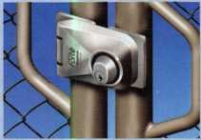

* Can be master-keyed
* Fits metal, wood & vinyl gates
* Limited Lifetime Warranty

The Security Lock with Style

The Forte™ Hasplock introduces a new standard in quality commercial and industrial locking security.

Forte HaspLocks (4 models) are designed for all types of storefront, door, gate and storage locking, either as add-on security for existing locks or as primary locks.

Made from 316-grade stainless steel, the Forte Hasplock is particularly ideal for use in marine or other corrosion-prone environments.

Forte Hasplock is highly resistant to hacksawing, levering and oxyacetylene cutting.

Vending machines using "hinged" models

Gate Security - no padlocks or chains

Toolboxes & Storage

Model: FHLSSR

me Ultimate  
Security Gate Latch

*n*

***a aa***

**LOKr LATCH**

Lokk»Latch® PRO is the most sophisticated privacy and security

gate latch ever devised. It is the privacy latch that locksmiths  
and security businesses have been raving about!

This quality, patented latch can be operated

and locked from either side of the gate!

Lokk*Latch PRO is uniquely constructed

to work effectively in both residential  
and commercial gate applications.

The "External Push-Button Access"  
component fits to the outside  
(street side) of the gate post to

provide convenient, key-lockable access.

It uses a standard 6-pin key-in-knob style lock cylinder. This cylinder can be keyed-alike, maison-keyed and master-keyed, or can be replaced with a high security cylinder.

GATE

POST



dbd ftEElnsigiDaqaES

**Safety, Privacy & Security**

D&D Technologies (USA) Inc., 7731 Woodwind Drive, Huntington Beach CA 92647  
Tel: (800) 716-0888 ext. 231 Fax:(800) 464-6400 E-mail: [gateware@ddtechusa.com](mailto:gateware@ddtechusa.com) Web: [www.ddtechusa.com](http://www.ddtechusa.com)



Quality

Endorsed

Company

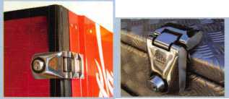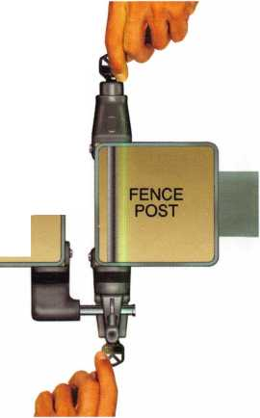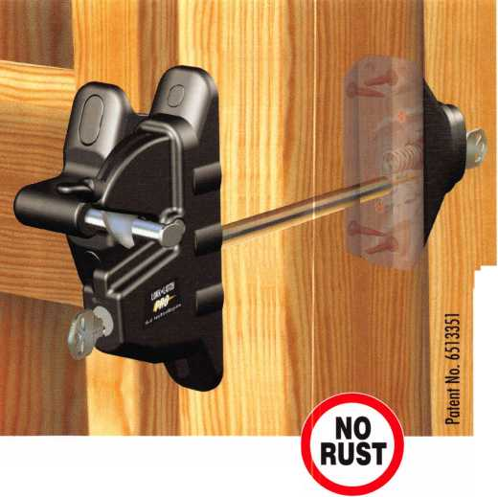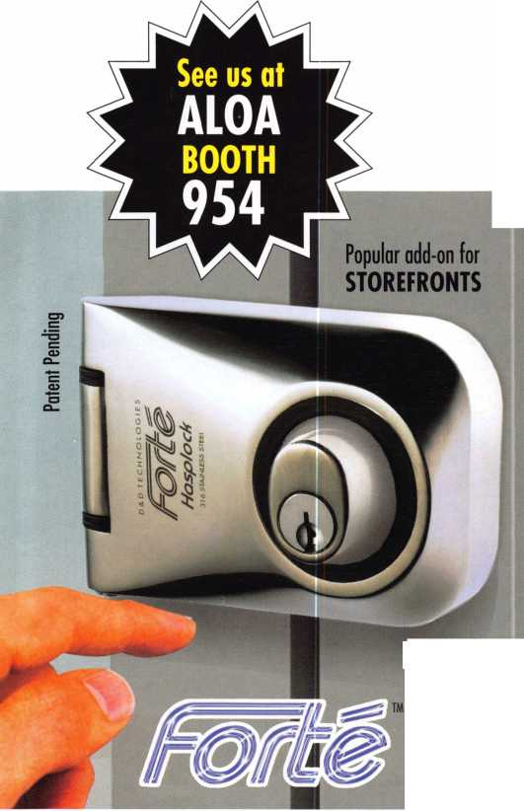

The 0afc and Vault Technicians 3ssociataion  
(Qonocntion and Trade 0hom

March (>—12, 200S

*Hyatt Regency, Lexington KY*

T>

Ml P^ey Mac, keeping up with the latest the industry has to offer has never been more important for us safe technicians. Let me tell ya, you gotta stay aware of what today's top safe distributors and manufacturers are putting out there. It's crucial to making a humdinger of a purchasing decision, buddy. And another thing, time is of the essence when it comes to education. New things pop up every day, Daddy-O, and that makes top-notch safe classes as good as gold. The only chance to get world-class education and meet with the industry's top distributors and manufacturers is the SAFETECH Convention and Trade Show. Boy, is it swell! SAFETECH 2005 offers you a chance to meet with potential customers and bolster business in ways you never thought possible. Discover the safes of tomorrow! Gee whiz, jump and jive your way into Safetech 2005, and you'll be part of our knock 'em, sock 'em show of all shows!!

*Safetech Oieite Beautiful Lexinqten, Kentuckul*

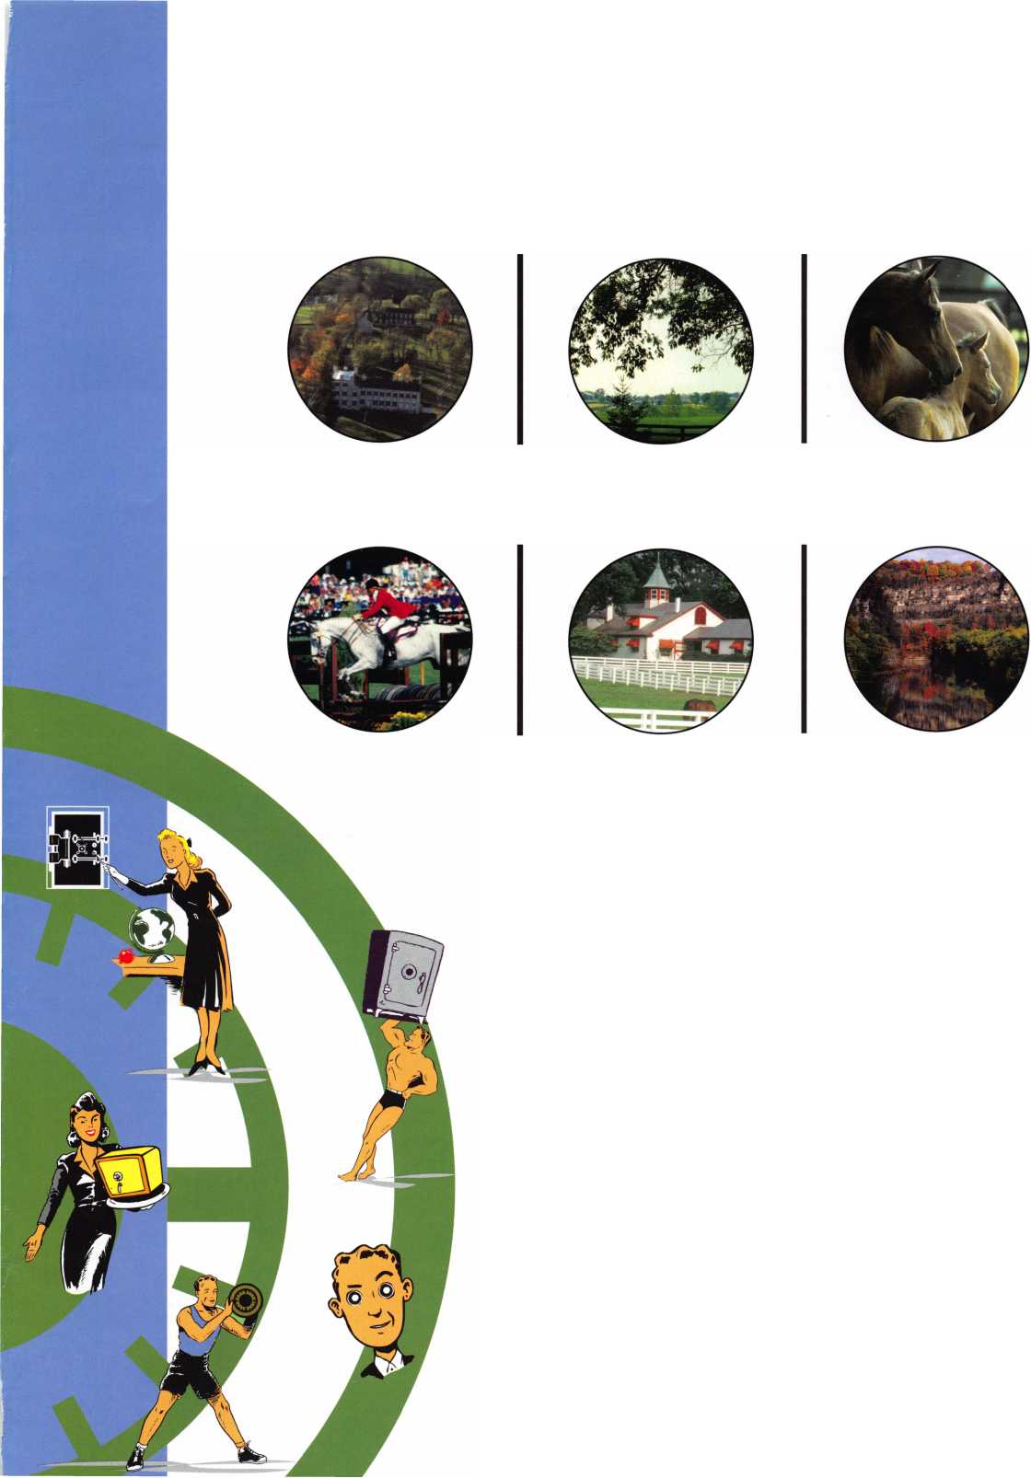

**presidential**

**viewpoint**

Dear Members,

It's hard to believe that summer is over, the kids are back in school,  
and it is time to get back to work at full speed. It's also hard to believe  
that I have completed one year in office already. I am very pleased  
with the cohesiveness of the board and our ability to get things  
accomplished.

It is my pleasure to welcome two new directors to the board, Jim  
Jeffries in the northwest and Vernon Kelley in the northeast. I am look-  
ing forward to the contributions from these new members, Jim for his

knowledge of the lock and safe community and Vernon for his input on institutional locksmith  
matters. I am also going to feel a great sense of loss in the departure of Scott Henke and John  
Cannon from the board. Scott was the inspirational leader of the board and John was a fixture  
and a fantastic secretary. I was honored to recognize the Henke family with the President's  
Award and to present John with his Life Member credentials at the general meeting.

For those of you who haven't heard, the 2004 convention in Baltimore was a fabulous show and a huge success. The ALOA staff deserves our utmost appreciation for organizing and car­rying out a wonderful event. Jo Anne Mims, our Convention and Meetings Manager deserves special mention and David Lowell once again put on an outstanding educational program.

The staff is constantly looking at ways to improve the convention, which means, that Chicago in 2005 will be even better.

A very important meeting took place in Baltimore in conjunction with our convention. It was chaired by John Cabiness of the National Automotive Service Task Force and was labeled "OEM - Locksmith Work Group Meeting". Basically, it was a meeting between automotive manufacturers and locksmith representatives to brainstorm ways that locksmiths can obtain the information needed to generate keys for late-model automobiles. Two very important things came out of this meeting. First, a Vehicle Security Committee was formed, with Paul Kanitra of ALOA and Mark Saxonberg of Toyota serving as co chairs. Secondly, a draft document was created to lay out the background for a proposal with the National Insurance Crime Bureau for a security professional directory. Many of the ALOA Board of Directors were present at the meeting until it conflicted with our general meeting. ALOA Legislative manager Paul Kanitra and directors Mark Blum and Tom Lynch remained in the meeting to ensure that ALOA's views were represented.

Sincerely,

William L. Young, CML, CP:

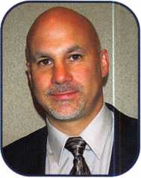

Keynotes • September 2004

■■■\\ I

Hivikii

| 0



tf :\%

**The HLOR**

**Conuention**

**and Security Expo July 17-24, 2005**

SLUEET

Get Ready for RLOR 2005,

a powerful resource to explore innouation and form industry alliances. This year we’ue thouyht of euerythiny from an excitiny location, comfort­able accommodations and a conuention center that is equipped to handle your euery need.

Located just minutes from downtown  
Chicago, Rosemont, II. is the  
perfect “business uillage”, designed specifically  
to make your stay conuenient, comfortable  
and aboue all, successful!

The 49th Rnnual RLOR Conuention and Security Expo  
offers top-notch classes, workshops, networking  
opportunities and cutting-edge technology.

Rnd don’t miss out on the fine dining and enter-  
tainment options that Chicago has to offer. Shop  
at the world-famous Magnificent Mile. Eat at  
Morton’s of Chicago or Harry Carry’s Italian  
Restaurant. Uisit the Nauy Pier or catch a ball  
game. The options are endless when you register  
today for the single-most important euentin  
the locksmithing industry.

Baby, you know you want to yo!



**RLOR 2005**

Sweet Home Chicago

111 .

*mm*|

f e

t

u

r

e

a

CRIME PREVENTION 2004



Partners in Crime...Prevention Neighborhood Watch and Crime Prevention

Sometimes, effective crime prevention must come from the public. Enter the neighborhood watch. What possible role can a lock­smith play in a Neighborhood Watch? What are the benefits of getting involved?

**24**

LKM 7000

Locks are designed to help keep the bad guys out. Codes are generally written to let everybody out. Safety versus security, they often clash. Federal government standards, commonly referred to as GSA standards, for storage of classified materials requires a lock approved under federal standards. byGregPerry

**14**

Who's Afraid of the 3-Point Door?

Three-point locking systems are manufactured by Peachtree and Anderson (among others] and, other than a basic rekeying job, they can be a royal pain to work on. But the next time you see one of these beasts looming over you, don't be afraid. Be informed! by Eric Costley, crl

**20**

Bank Equipment Field Service:

Combination Lock Manipulation

True manipulation of combination locks is the successful determination of a combination through general knowl­edge of how the lock works and specific knowledge of how that particular lock responds. The manipulator with the capacity to master these skills is defeated only by mechanical failure, by Brian p. Smith

**30**

The ALOA 2004 Convention and Security Expo Wrap Up

"As the future of locksmithing extended before the eyes, we were showered with new tools, new electronics, advanced software, innovations in safes, and a multitude of unique ideas brought to us by the experts in our industry." by Claire Cohen, CML

**44**

The Curious Curator

Presents French Masterpieces part 2 of 2 ByajHoffman, cml

**Departments**

|  |  |  |  |
| --- | --- | --- | --- |
| Executive | 5 | Calendar | 8 |
|  |  | Legislative |  |
| Core | ...23 | Update | 38 |
|  |  | Classified | 40 |
| Applicants ... | 6 | Associate |  |
|  |  | Members | 42 |

Visit our website at [www.aloa.org](http://www.aloa.org)



**executive**

Volume 50, Issue 8



Additional contact information for the ALOA Board and most Keynotes authors is  
available through "Locksmith Search7" on the ALOA Web site- [www.aloa.org](http://www.aloa.org) or by  
contacting the ALOA office at 3003 Live Oak Street; Dallas, TX 75204; (800)532-2562;  
FAX (214)827-1810; e-mail [aloa@aloa.org](mailto:aloa@aloa.org).

Publications Manager

Betty Henderson [betty@aloa.org](mailto:betty@aloa.org)

Technical Editor

David Lowell, CML, CMST [david@aloa.org](mailto:david@aloa.org)

Editorial Advisor

John Cannon, CML [secretary@aloa.org](mailto:secretary@aloa.org)

Advertising Sales

Kim Hammond voice: 817-645-6778

Fax: 817-645-7599 e-mail: [adsales@aloa.org](mailto:adsales@aloa.org)

Executive Director

Charles W. Gibson, Jr., CAE [charlie@aloa.org](mailto:charlie@aloa.org)

Associate Executive Director

David Lowell, CML, CMST [david@aloa.org](mailto:david@aloa.org)

Convention & Meetings Manager

Jo Anne Mims [joanne@aloa.org](mailto:joanne@aloa.org)

Operations/Membership Manager

Mary May [mary@aloa.org](mailto:mary@aloa.org)

Government Relations Manager

Paul Kanitra [paul@aloa.org](mailto:paul@aloa.org)

IT Operations Manager

Greg Jackson [greg@aloa.org](mailto:greg@aloa.org)

Comptroller Kathy J. Romo

Membership Coordinator Shelly Jett

Convention & Meetings Assistant Karen Lyons  
PRP/Education Coordinator Hope Rodriguez

Accounting Coordinator Essie Goode

Mail Room Coordinator Kevin Wesley

Publications Coordinator Bryan Dease

Executive Assistant Sue Langford

Receptionist Wendy Wilder

Contributors

Jerome Andrews, CML  
Paul Chandler, CRL  
Claire Cohen, CML  
Brian Costley, CML, CMST  
Eric Costley, CRL

Ray D'Adamo, CML Billy Edwards, CML Dan Graffeo, CRL,CMST Jim Hancock, CRL Jeff Nunberg, CML, CMST

Randy Simpson, CML Robert Stafford, CML Dave Thielen, CML Greg Perry, CML,CPS

Tom Seroogy

Charles Stephenson, CPS

Dennis Watanabe, CML, CMST

Mission Statement: The Associated Locksmiths of America, Inc. is dedicated to enhancing the professionalism, education and ethics among  
locksmiths and those in related sectors of the physical security industry. With approximately 10,000 members in the United States, Canada and the  
freeworld, ALOA is poised to help members obtain the knowledge, the strength, and the confidence to perform their role in the physical security field  
with pride and dignity. But it is only through active involvement and participation that ALOA can fully achieve its potential—and can help members to  
achieve theirs.

Policies: **Keynotes**® is the official publication of the Associated Locksmiths of America, Inc. (ALOA). **Keynotes**® acts as a moderator without approving,  
disapproving, or guaranteeing the validity or accuracy of any data, claim, or opinion appearing under a byline or obtained or quoted from an acknowl-  
edged source. The opinions expressed by the authors do not necessarily reflect the official views of ALOA. Also, appearance of advertisements and  
new products or service information does not constitute an endorsement of products or services featured by the Association. The Association does not  
accept responsibility for the inaccuracy of any data, claim, or opinion appearing in this publication, due to typographical errors on the part of the  
authors, Association staff or its agents.

Editor's Note: This publication is designed to provide accurate and authoritative information in regard to the subject matter covered. It is provided  
and disseminated with the understanding that the publisher is not engaged in rendering legal or other professional services. If legal advice and other  
expert assistance is required, the services of a competent professional should be sought.

Authors' Payment: Payment for eligible submissions to Keynotes will be based on the following criteria: topic, time spent and past contributions. Authors who  
regularly submit to **Keynotes**® are generally paid a higher rate. The latter is especially true of authors who write to fit specific editorial needs and submit said copy  
by **Keynotes**® deadlines. As a general guideline: Average payment for a 750 word, business or light' technical article would be $200. Payment for a 1500 word  
article involving significantly higher time and research efforts would be $400.

Payment will not be offered for articles submitted by ALOA employees or members of the ALOA Board of Directors (unless material is of a technical  
nature), nor for articles submitted by a company that promote that company's products or services. ALOA reserves the right not to pay for articles sub-  
mitted by an individual(s) that promote a particular company's products or services.

Disclaimer: The Associated Locksmiths of America, Inc., (ALOA), reserves the right to refuse any article for any reason. Additionally, ALOA reserves  
the right to edit, amend or modify any article submitted for publication in order to preserve technical accuracy, clarity, fairness or grammatical cor-  
rectness. ALOA will make the best efforts to notify the author of any changes. The extent of ALOA's liability for any article or information contained  
therein will be a notice of correction or retraction in the next possible issue.

**Keynotes**® (ISSN 0277 0792) is published monthly except for the combined June/July issue by The Associated Locksmiths of America, Inc.,  
3003 Live Oak St., Dallas, TX 75204-6186. Telephone: (214) 827-1701; FAX (214) 827-1810; e-mail [aloa@aloa.org](mailto:aloa@aloa.org). Subscription rates for  
members—$15.00 per year. Periodical class postage paid at Dallas, Texas. POSTMASTER: Send address changes to: Keynotes, 3003 Live Oak St.,  
Dallas, TX 75204-6186. © Copyright 2003, All rights reserved. No part of the contents may be reproduced or reprinted in any form without prior  
written permission of the publisher.

President

William L. Young, CML  
(610)647-5042  
[president@aioa.org](mailto:president@aioa.org)

Secretary

John Soderland, CML, CMST  
(414)327-5625  
secretary@dloa. org

Directors/ Northeast

Robert E. Mock

(856) 863-0710  
[nedirecfor@aloa.org](mailto:nedirecfor@aloa.org)

Peter Saraifian, CRL  
(973)890-9797  
[nedirector@aloa.org](mailto:nedirector@aloa.org)

Vernon Kelley, CPL  
(609) 771-3126  
[nedirector@aloa.org](mailto:nedirector@aloa.org)

Directors/ Southeast

Tom Gillingham, Jr., CML, CPS  
(615)264-0747  
[sedirector@aloa.org](mailto:sedirector@aloa.org)

Ken Kupferman, CPL  
(813)961-5784  
[sedirector@afoa.org](mailto:sedirector@afoa.org)

Director, North Central

Mark E. Blum, CML, CPS  
(517) 482-5809  
[ncdirector@aloa.org](mailto:ncdirector@aloa.org)

Director, South Central

CD Lipscomb, CML, CPS  
(903)874-3522  
scd i recf6r@aloa. org

Directors, Southwest

Gordon R. Racine, CML  
(719) 384-4707  
[swdirecfor@aloa.org](mailto:swdirecfor@aloa.org)

Julie McCluney, CRL  
(714) 636-5652  
[swdirecfor@aloa.org](mailto:swdirecfor@aloa.org)

Director, Northwest

Jim Jeffries, CPS  
(208)743-1101  
[nwdirector@aloq.org](mailto:nwdirector@aloq.org)

Director, European

Hans Me|lshede, CML  
(453)539-3939  
[eurdirector@aloa.org](mailto:eurdirector@aloa.org)

Director, Asian

JoeJ. Lee, CRL  
(215)289-2404  
[qsiandirector@aloa.org](mailto:qsiandirector@aloa.org)

Director, Associate

Paul M. Justen  
(800)333-6953  
[asdirector@aloa.org](mailto:asdirector@aloa.org)

Trustees

[trustees@aloa.org](mailto:trustees@aloa.org)

Randy Simpson, CML  
(281)240-5959

John J. Greenan, CML, CPS  
(773) 486.2030

Dallas Brooks  
(334) 826-8990

Past Presidents

2001-2002 Randy Simpson, CML  
1999-2001 John Greenan, CML, CPS  
1997-1999 Dallas C. Brooks  
1995-1997 David Lowell, CML, CMST  
1993-1995 Breck Camp, CML  
1991-1993 Henry Printz, CML  
1989-1991 Evelyn Wersonick, CML, CPS  
1987-1989 Leonard Passarello, CPL  
1985-1987 Joe Jackman, CML  
1983-1985 Stanley Haney, CPL  
1981-1983 Louis LaGreco, CPL  
1979-1981 John Kerr, RL  
1977-1979 Clifford Cox, CML  
1974-1977 Charles Hetherington  
1972-1974 Gene Laughridge  
1970-1972 William Dutcher, RL  
1968-1970 Constant Maffey, RL  
1966-1968 Harold Edelstein, RL  
1964-1966 William Meacham  
1962-1964 Robert Rackliffe, CPL  
1960-1962 Edwin Toepfer, RL  
1956-1960 Ernest Johannesen



Keynotes • September, 2004

**applicants**

for membership

FPO

David K. Moyer

Calera

Jimmy Lowe

Sponsor: Danny C. Booth

Conway

Phillip Joiner

Sponsor: Brooke P. Berry CRL

Atwater

Arturo M. Uribe

Sponsor: Sharon L Roper

Hesperia

Rick L Pardue

Sponsor: Charles E. Brown

Sunland

Dennis Hilligoss

Sponsor: James Kleman CPL

Parker

Jeffrey A. Rubin

Willimantic

Brenda J. Beattie

Sponsor: Michael A. Beattie CML

Shawn P. Beattie

Sponsor: Michael A. Beattie CML

Washington

Christopher Rothenberg

Sponsor: Michael J. Conway

Wilmington

Peter T. Verne

Sponsor: Douglas R. Murray

Callahan

Michael L. Gaynor

Sponsor: Daemien C. Romano

Hallandale

Glen Wauchope

Atlanta

Roberto Selcis

Cave Spring

Mark Powell

Dublin

Randy E. Odom

Sponsor: Robert D. DeWeese CML

Bettendorf

Donald E. Todd

Sponsor: Donald S. Fritz

Baltimore

Las Vegas

Fred Beall Aquiles D. Tan Jr

Sponsor: Randolph A. Perry CML Sponsor: Bruce P. Eagan CML

Burtonsville

Lutther W. Cowan Sr.

Sponsor: Philip A. Rovenolt CPL Cleveland

**006011 Cily** Abdul Redo Bazzi

Barbara Dement Sponsor Emir Y. Abeid RL

Detroit

Michael A. Wisniewski

Sponsor: Salvatore J. Dulcamaro CML

Grand Rapids

James Ryan

Sponsor: Bradley J. Polega CRL

Champlin

Willie Givens

Eden Prairie

David Lawrence

Sponsor: Robert J. Lawrence

New Brighton

Vince Gonzalez

Sponsor: Elvis D. Hammerschmidt CPL

Columbia Falls

Karl S. Weeks

Malvern

Nick Vone

Sponsor: Chris A. Strauss

Tyler Ain ley

Sponsor: Chris A. Strauss

Gene Griffith

Sponsor: Chris A. Strauss

Port Orchard

Larry Trail

Cairo

Alaa EldinYahya Atwa

Sponsor: Ahmed M. Raslan

Nashville

John Muir II

Fort Worth

Derrick Timms

Chesapeake

Carl Volz

Sponsor: Clifford D. Lipscomb CML, CPS

Ba rrow-i n-F u r nessC u

Andrew Rae

Sponsor: Ken Dale

London

Keith A. Ryalls

Sponsor: Ken Dale

Hong Kong

Chim Yue Wilson

Sponsor: Kwok-kei Leung

Galway Co Galway

Scott Wright

Sponsor: Mark Irwin

Rieti

Riccardo Loreti

Sponsor: Aldo Casiraghi

Tyngsboro

Steve Joyal

These applicants are scheduled for clearance as members of ALOA. The names are published for member review and comment within 30 days of this Keynotes issue  
date, respectively, to ensure applicants meet standards of ALOA's Code of Ethics. Protests, if any, should be addressed to the Membership Department and must be  
signed. Active Membership applicants (a) have worked in the industry two or more years. Allied Membership (AL) applicants are not locksmiths, but work in a security-  
related field. Apprentice Membership (AP) applicants have worked in the industry less than two years.

ACCESS ABILITY

Ability to get the best.

Security’s Electronic Access Group can provide everything you need to design and integrate the most complex and demanding access control system - the ideal components, from every major manufacturer - right down to the wiring. That’s single-source supply, with technical knowledge and immediate availability and shipping. Rely on Security Lock Distributors and you’ve got the ability to do your best.

1-800-847-5625

[www.securitylockdistributors.com/email](http://www.securitylockdistributors.com/email): [info@seclock.com](mailto:info@seclock.com)  
Boston, MA • Pompano Beach, FL • Las Vegas, NV

SECURITY

LOCK DISTRIBUTORS

Informed. In depth.

¥mf

I '* C * * t S t ft T I I

Eftl Altronix

: J1 m- \im

- L L

Ids] detection systems

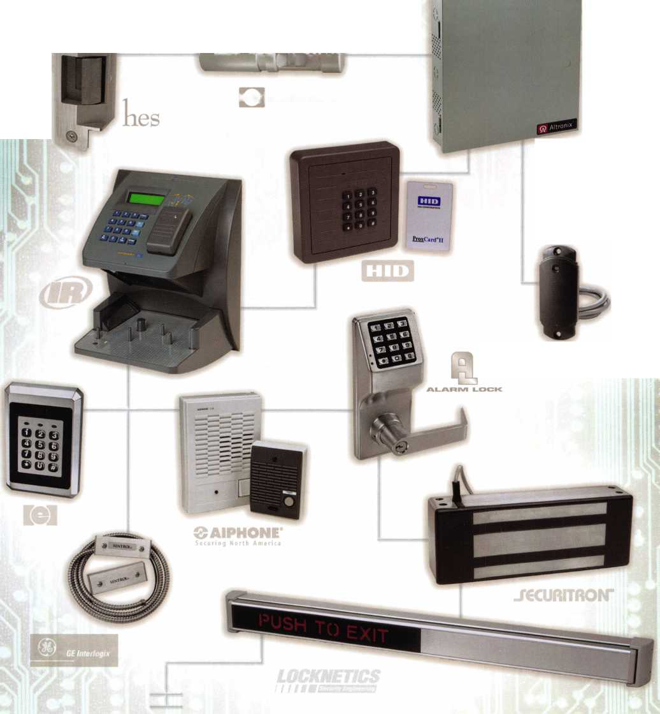

**NOVEMBER I OCTOBER SEPTEMBER**

upcoming events

|  |  |
| --- | --- |
| New York Master Locksmiths' Assoc. Monthly Meeting  Every Second Wednesday NYC/Long Island Area  718 274-6930 | 1 Minnesota Chapter of ALOA 1 Ohio Valley Chapter of ALOA 10 & 1 1  Regular Meeting, Dinner 6:00 PM, Monthly Meeting TAOL 32nd convention  Meeting 7:00 PM, Program: GE Ryan's Steakhouse Sheraton Parkway Toronto North  Security Middleton, Ohio Richmond Hill, Ontario Canada  513-464-1299 [www.taol.net](http://www.taol.net) |
| 29-3 SERLAC 2004  Orlando, Florida  Classes & Trade Show |  |
| New York Master Locksmiths' Assoc. Monthly Meeting  Every Second Wednesday NYC/Long Island Area  718 274-6930 | 6 Ohio Valley Chapter of ALOA 6 Minnesota Chapter of ALOA 12-16 Pacific Locksmith Conference-  Monthly Meeting Regular Meeting, Dinner 6:00 PM, Portland, Oregon  Ryan's Steakhouse Meeting 7:00 PM, Program: MN  Middleton, Ohio Sales Tax or Homeland Security  513-464-1299 |
| 13-16 Institutional Locksmiths' Assoc. 2004 ILA Conference  The Hotel Roanoke and Confer­ence Center - Roanoke, VA | 27-30 GPLA Annual Convention 27-31 GPLA 2004 Convention  Radisson Hotel • Mt. Laurel, NJ Radisson Hotel Mt. Laurel, NJ  [www.gpla.org](http://www.gpla.org)  Exhibitors call Edward Fitzgerald,  CML at 856.665.1311 |

|  |  |
| --- | --- |
| New York Master Locksmiths' Assoc. Monthly Meeting  Every Second Wednesday NYC/Long Island Area  718 274-6930 | 3 Ohio Valley Chapter of ALOA 3 Minnesota Chapter of ALOA  Monthly Meeting Regular Meeting, Dinner 6:00 PM,  Ryan's Steakhouse Meeting 7:00 PM, Program: MN  Middleton, Ohio Sales Tax or Homeland Security  513-464-1299 |
|  |  |

You need it When?

**How about now!? :-)**



Another Special  
Value-added Benefit to your

ALOA Membership! Click here

[www.clearstar.com](http://www.clearstar.com) / ALOA

V

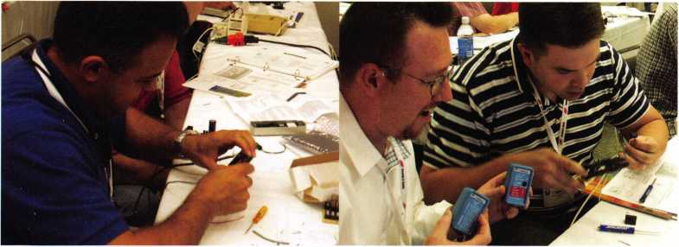

UPCOMING ACE CLASSES

|  |  |  |
| --- | --- | --- |
| 9/11/2004 | Gulfshores, AL • Alabama Locksmiths Association  DLee Schofield 334-832-4920 • Life Safety Codes w/L-07 PRP  Complete Door & Door Closers w/L-05 PRP |  |
| 9/11/2004 | Detroit, Ml • Locksmith Security Association • Robert Nobel, CPL 810-385-9329 • Tubular Key Locks w/L-12 PRP | 10/20-24/2004 |
| 9/17-18/2004 | Biloxi, MS •Lou-Miss Convention • Jim Hancock, CPL  512-472-6273 • Small Format Interchangeable Core, Basic Electricity,  Life Saftey Codes, Basic Access Control |  |
| 9/18/2004 | Atlanta, GA • Georgia Chapter of ALOA • Kevin Wilson, CML,CPS 770-279-1161 • Life Safety Codes w/L-07 PRP | 10/25-30/2004 |
| 9/18-19/2004 | Syracuse, NY • Central NY Locksmiths Association  Ron Smith, CRL, CPS 315-782-0912 • Alternate Entry Techniques  Keyless Mechanical Locks w/L-20 PRP | 11/13/2004 |
| 9/25/2004 | Casper, WY • Wyoming Locksmiths Association • Darin McFarland 307-587-3035 • Advanced Shop Management | 11/13/2004 |
| 9/25/2004 | Kalamazoo, Ml • Western Michigan Locksmith Assn.  R. Paul Bentley, CPL 269-327-8400 • Basic Electricity w/L-13 PRP  Access Control | 11/13/2004 |
| 10/7-8/2004 | Omaha, NE • MINK Convention • Bernard Dobesh 308-381-4440  CPS Prep Class <http://www.nebraska-locksmith.com/> | 11/20/2004 |
| 10/12-16/2004 | Portland, OR • Pacific Locksmiths Association • Tom Jones, CRL 503-842-2944 • Basic Locksmithing 1 & II (twice) <http://www.pla-pro.org/plc/index.htm> • Life Safety Codes w/L-07 PRP Servicing Aluminum Storefront Doors  Master Keying Methods & Formats 1 & II  Late Model Steering Column Service • Power Door Openers  Hollow Metal Doors & Frames • Intermediate Auto Lock Service | 12/4/2004 |
|  | Exit Devices & Exit Alarms w/L-16 PRP |  |

Professional Impressioning Techniques • Transponders The Complete Door & Door Closers w/L-05 PRP Professional Lock Picking

Sturbridge, AAA • Yankee Security Convention • Jack Hobin

800-209-8266 • The Complete Door & Door Closers w/L-05 PRP

[www.yankeesecurity.org](http://www.yankeesecurity.org) [info@yankeesecurity.org](mailto:info@yankeesecurity.org)

Basic Locksmithing I, II & III • High Security Cylinders w/L-08 PRP

Exit Devices & Exit Alarms w/L-16 PRP • Basic Electricity w/L-13 PRP

Keyless Mechanical Locks w/L-20 PRP • Tubular Key Locks w/l-12 PRP

Appleton, Wl • Fox Valley Technical College • Jerry Antoon P-

920/735-2406 • 6 Day Basic Locksmithing Course

Fox Valley Technical College F-920/735-2414

Atlanta, GA • Georgia Chapter of ALOA • Kevin Wilson, CML,CPS

770-279-1161 • PRP Prep Class

Detroit, Ml • Locksmith Security Association • Robert Nobel, CPL 810-385-9329 • Combination Lock Servicing w/L-24 PRP Kalamazoo, Ml • Western Michigan Locksmith Assn.

R. Paul Bentley, CPL 269-327-8400

Complete Door & Door Closers w/L-05 PRP

St Louis, MO • Bi-State Chapter of ALOA • Robert Theobold

314-340-6801 • Alternate Entry Techniques

Birmingham, AL • Alabama Locksmiths Association • DLee Schofield 334-832-4920 • Simplex Unican Certification

UPCOMING PRP SITTINGS

|  |  |  |  |
| --- | --- | --- | --- |
| 9/9/2004 | Thursday 8:30am • Dallas, TX • ALOA • Hope Rodriguez 800-532-2562x30 | 10/23/2004 | Saturday 9:00am • Sturbridge, MA • Yankee Security Convention • Jack Hobin 800/209-8266 |
| 9/25/2004 | Saturday 9:00am • Houston, TX Greater Houston Locksmiths Association • Judy Clifford • 979-297-2413 | 10/31/2004 | Sunday 10:00am • Mt Laurel, NJ • GPLA  Robert J. Schuetrumpf, CRL856-486-9280 |
| 10/2/2004 | Saturday 9:00am • Colorado Springs, CO  Central & Southern CO Locksmith Assn | 11/13/2004 | Saturday 8:00am • Cary, NC • NC Locksmiths Assn  Granger L. Marley, CML 919-859-6060 |
|  | Gordon Racine, CML 719-384-4707 | 11/14/2004 | Sunday 1:00pm • Robinsonville, MS • Tennessee |
| 10/3/2004 | Sunday 8:00am • Anaheim, CA • Clark Security Products Joan Emrick 619-718-7308 |  | Organization of Locksmiths • Jim Weidman, CPL 615-837-1264 |
| 10/3/2004 | Sunday 9:00am • Brandon, FL • SERLAC  James Barnhardt, RL 813-689-5979 | 11/11/2004 | Thursday 8:30am • Dallas, TX • ALOA • Hope Rodriguez 800-532-2562x30 |
| 10/10/2004 | Saturday 8:00am • Omaha, NE • MINK Convention  Bernard Dobesh 308-381-4440 | 11/20/2004 | Saturday 8:00am • Atlanta, GA • Georgia Chapter of ALOA Kevin Wilson, CML,CPS 770-279-1161 |
| 10/14/2004  10/15/2004 | Thursday 8:30am • Dallas, TX • ALOA • Hope Rodriguez 800-532-2562x30  Friday 6:00pm • Portland, OR • Pacific Locksmiths Assn  Dan Cunningham, CRL 360-835-7131 | 12/9/2004 | Thursday 8:30am • Dallas, TX • ALOA Hope Rodriguez 800-532-2562x30 |

**neigiwornood waicn**

and HIP

**Home Security**

**artners in crim e...** prevention

In an age where security has become a national concern, the need for feelings of safety on a personal level has reached an all-time high. Far gone are the days of leaving your front door unlocked while making a run to the cor­ner grocery. So, with the rising fear of crime comes the need for more effective crime prevention. National gov­ernment agencies are working hard to keep the public alert, and the local police strive to keep criminals off the streets. But sometimes, effective crime prevention must come from a different source: the public. Enter the neigh­borhood watch. Most people are familiar with this con­cept, but few really seem to understand the benefits it can provide to those who choose to begin such a pro­gram in their own neck of the woods. This is where the locksmith takes his cue.

A properly trained and rep­utable locksmith becomes an authority on personal safety.

What possible role can a locksmith play in a Neighborhood Watch? And what are the benefits of getting involved? Well, when it comes to security, who knows more than a locksmith? A properly trained and reputable locksmith becomes an authority on personal safety. You know the ins and outs of locks, which ones work the best and the proper way to install them.

I Fast Facts 1

1. Most burglaries are committed in broad daylight and nearly one-third of them occur through unlocked doors or windows.
2. Some illegal entries occur by use of a former occu­pant's key
3. Approximately one-half of all forced entries are made without the use of a tool.
4. The average time spent entering a home to commit a burglary is less than three minutes.
5. Neighborhood Watch and home security go hand in hand. The addition of good locks and increased security measures require the burglar to take more time and more noise to enter. This increases the likeli­hood that neighbors will notice and call 911.

This gives you an instant platform to be able to speak to those in your community about public safety. How will this benefit you as a locksmith? It would grant you an instant connection to the community you serve. When people see that you are actively working to inform them on how better to protect themselves and their families, they will come to trust you as a valuable resource. Word of mouth and solid reputation are invaluable tools to gen­erate business.



Keynotes • September 2004

Its one thing to have tools such as these at your dis­posal, but it will take a few creative ideas to make the wheels start turning. First, you should find out what neighborhood watches already exist in your area. Most of the time you can find this out by contacting your local police department. Many of them have offi­cers that work specifically with public watches. Secondly, put something in the hands of the people. Creating a simple flyer or brochure with burglary sta­tistics and security tips can be an informative way to advertise your services.

When people see that you are actively working to inform them on how better to protect them­selves and their families, they will come to trust you as a valuable resource.

The goal of a flyer should be to convince homeowners  
of the value and security provided by proper locks.

The great thing is, they don’t even have to take your  
word for it. The National Crime Prevention Center  
has put together a short press release that answers  
common objections the average person may have  
when it comes to the importance of proper safety fea-  
tures (page 12). If you need help in designing an effec-  
tive flyer, ALOA has done the work for you! There  
is a template provided in Microsoft Word format  
that you can download and use for your company.  
Simply replace the template logo with your own, and  
add any information you would like about your  
services. To get this template, visit ALOA’s website  
at [www.aloa.org/forms/security](http://www.aloa.org/forms/security). Then click on  
the “download security flyer” link.

An additional option you may consider is offering  
a free home security inspection to the public to go  
over these lists. These ideas may require a small invest-  
ment of time and money, but the effort will go a long  
way in the eyes of the public.

I Home Security Checklist 1

1. Are all exterior doors (including the garage) strong enough to withstand excessive force?
2. Are exterior doors secured with a deadbolt lock that has a minimum one-inch throw?
3. Are sliding glass doors and windows secure against forcing the locks or lifting the doors out of their frames?
4. Are garage doors secured (overhead and side door leading into garage)?
5. Are double-hung windows secured with pins or extra locks to discourage prying?
6. If moving to a new residence, did you hire a reli­able locksmith to re-key all exterior doors? If possi­ble, have the locksmith make one key to fit

all locks?

Advertise with Weatherproof Safety Labels!

Lockout your  
competition

by placing your  
calling card on  
every door you  
service! Keep

your name in front  
of every customer  
with these Durable,  
Affordable Labels  
Call & Order Today  
1-800-355-6322

(Actual Label Size 1 1/2x4 1/2)

Professional Business Products

ALOA Associate Member

BUYING FROM NEBS? We offer lower prices on Invoices, Checks, Business Cards, Repair Tags, Magnets, Key Tags, Pens and Labels. Come see us in Baltimore at the ALOA Security Expo Booth 854

[www.pbp2000.coin](http://www.pbp2000.coin)

Keynotes • September 2004

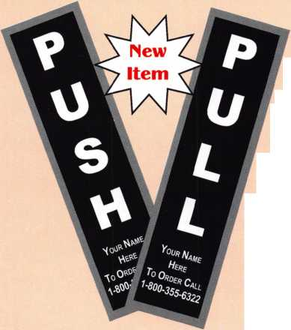

Common Objections Answered

High security locks are too expensive...

What did you pay for your last pair of running shoes? We have become accustomed to paying high prices for certain items, but because of the inexpensive imported hardware we have allowed to become “standard” in our homes, we often overlook the true value of a good lock. Be willing to pay as much for your lock as you do for your shoes.

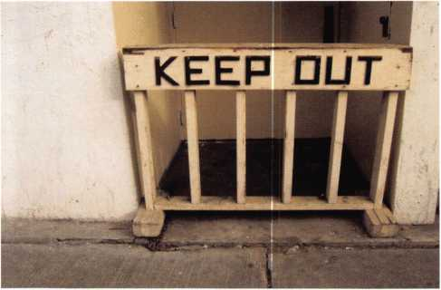

If a thief wants in, hell just break a window...

More than half of all residential break-ins occur through a first floor door. Less than 1/4 occur through a window.

We've done the work for you! This sample flyer is available for download online. It comes in Microsoft Word format. Simply replace the template logo with your own, and change any info you desire. Get it on the web at: [www.ALOA.org/forms/security](http://www.ALOA.org/forms/security).

Thieves don’t want to make the noise required to break a window, nor do they want to risk personal injury from the broken glass. A thief’s preferred method of entry is by quickly getting through a vulnerable or unlocked door. If you have many easily accessible first floor windows, con­sidering adding window film or a motion detector to your security system.

I have an alarm; I dont need good locks...

Would you purchase a car with airbags but no brakes? While the airbag protects you if you hit something, the brakes attempt to keep you from hitting anything at all. Locks and alarms are the same. Alarms notify authorities if a break-in occurs. Good locks can prevent a crime from happening at all.

I dont have anything to protect...

The average residential break-in creates about $1,500 in losses, much of which the homeowner pays due to insur­ance deductibles and non-covered items. The emotional stress of having a home violated is an element that is often overlooked but is terribly traumatic for most crime vic­tims. The risk of accidental or intentional injury to an inhabitant of a house during a break-in is also very great. Don’t underestimate the value of your life or health!

IS YOUR HOIRE SECURE?

some little known statistics...

1. Most burglaries are committed in broad daylight and nearty one-third occur through unlocked doors or

2 Some illegal entries occur by use of a former occupant’s key

3. Approximately half of all forced entries are made without the use of a tod.

1. The average time spent entering a home to commit a burglary is less than three minutes
2. Neighborhood Watch and home security go hand in hand

The addition of good locks and increased security measures require the burglar to take more time and more noise to enter This increases the likelihood that neighbors wid notice and cal 911.

how can I check to see if my home is secure?

1 Are ad exterior doors (including the garage) strong enough to withstand excessive force?

1. Are exterior doors secured with a deadbolt lock that has a minimum one-inch throw?
2. Are aH strike plates and frames for each door strong enough to withstand excessive force?
3. Are sliding glass doors and windows secure against forcing the locks or lifting the doors out of their frames?
4. Are garage doors secured (overhead and side door leading into garage)?
5. Are double-hung windows secured with pins or extra locks to discourage prying?
6. If moving to a new residence, did you hire a reliable locksmith to re-key ad exterior doors? If possible, have the locksmith make one key to ft ad locks?



**Bryan's Lock and Key**

214-WE-SEOIltE  
2111 **any** Si.

D ALIAS, TX 75204

Bryan's Lock & Key

- has been in the security business for 20 years. We see it as our responsibility to help the community of Rockwall, TX feel more secure by providing the highest quality home security devices and installations that are available today. Give us a call at (214)-WE-SECURE. We will be glad to offer you a free home security inspection - and explain dearly to you the best way to secure the safety of you and your family.

**2**

Keynotes • September 2004

*first mechanical re tets/ou know your*

***■port. Lifetime Gum***

O Green = L0 O Red = Lock

***Products***

***C£L ^Security***

**SearchAisi**

**Lock all of your checked luggage**

*withoutflr»aM*

Know Who Searched Your Belongings

CCL Security Products' new SearchAlert™

RE-SETTABLE COMBINATION LOCK WAS DESIGNED WITH A SECURITY FEATURE WHICH ALLOWS TSA AGENTS, USING A SECURED ACCESS DEVICE, TO OPEN THE

SearchAlert lock without destroying the lock.

The new SearchAlert Security window changes

COLOR FROM GREEN TO RED WHEN THE TSA SECURED ACCESS DEVICE IS USED TO OPEN THE LOCK, OR WHEN AN UNAUTHORIZED PERSON HAS OPENED THE LOCK USING A COUNTERFEIT OPENING DEVICE.

Travelers will now know when their SearchAlert

LOCKS HAVE BEEN OPENED, AND WHETHER THEIR BAGS HAVE BEEN SEARCHED BY A TSA AGENT, OR VIOLATED BY AN UNKNOWN PERSON.

PRESTOLOCK® 8c PRESTOSEAL“

USE FOR ALL YOUR CARRY-ONS AND EVERYWHERE ELSE YOU TRAVEL

**TRAVEL SENTRY**

CERTIFIED

301 West Hintz Road • Wheeling, IL 60090 Telephone: 800.733.8588 • Fax: 847.537.1881 [www.cclsecurity.com](http://www.cclsecurity.com)

SearchAlert

Re-settable combination

Available in 4 colors:

Black: model #7400PSB White: Model #7400PW I Bright Nickel: Model #7400BN Pewter: Model #7400PTR

I SearchAlert, U.S. Patents I Pending

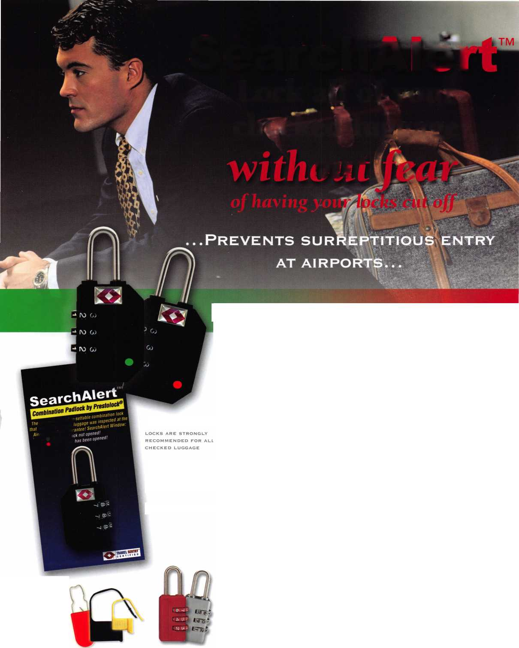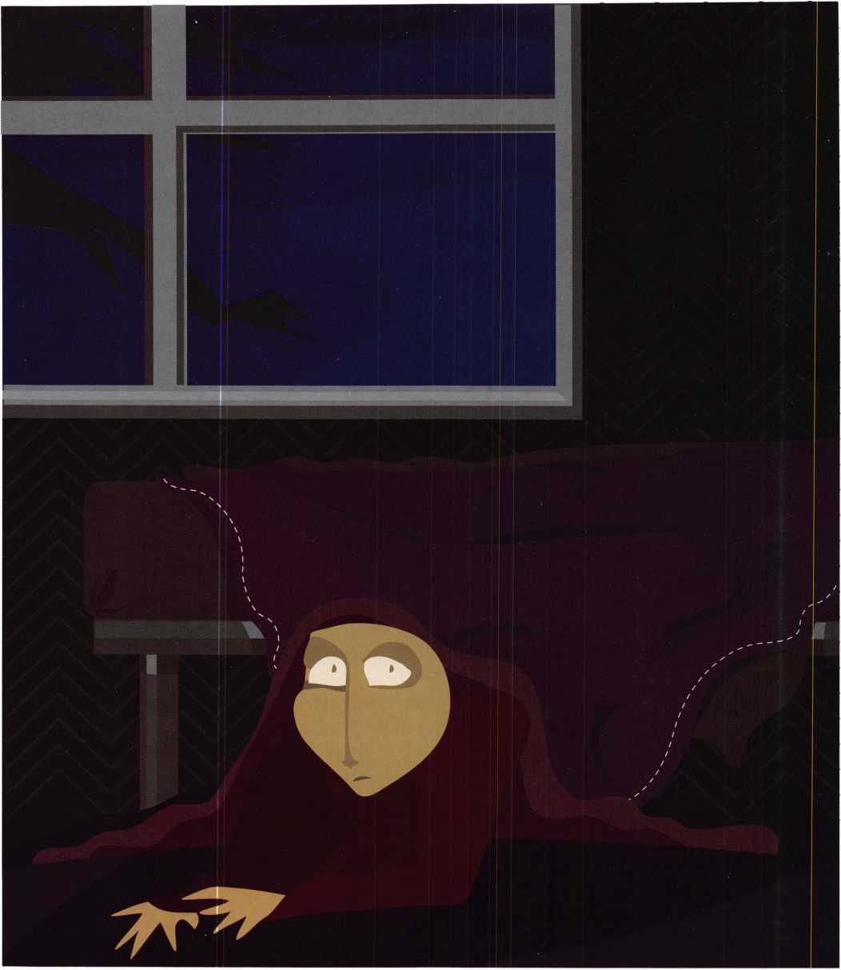

Who’s afraid of the 3 point door?

by Eric Costley, CRL

Keynotes • September 2004

Three point locking systems are manufactured by Peachtree  
and Andersen, (among others, but these are the ones I see  
most commonly,) and other than a basic rekeying job, they  
can be a royal pain to work on. Both of these use a mortise-  
style lock in the center of the door, with upper and lower  
locking extensions which are activated by the central mortise  
lock. In the case of the Anderson, the lever handle is lifted  
and the thumb turn then locks the bolts in place.

In the Peachtree design, one

only has to turn the thumb-  
turn to activate all three  
locking points.

With the door open, the  
differences are obvious.

Peachtree uses upper and  
lower modules with spring  
latch assemblies. The  
Andersen uses hook-like  
bolts which lock into  
strikes in the frame. In  
either case, any problem  
with the door that requires  
parts results in a call direct-  
ly to the manufacturer. I  
have learned over the years  
that it is much less painful  
and time consuming to let  
the customer deal directly  
with the manufacturer: I  
simply relay to the cus-  
tomer what is required, and  
they pass the information

on to the manufacturer. In this way, I avoid navigating  
the maze of phone menus, extended quizzing, and general  
discomfort. Both of these companies seem to respond  
quicker and with more courtesy to their end user. In  
many cases, they will ship parts directly to your customer  
at no charge, and Peachtree invariably also includes a  
VHS tape that details disassembly, alignment and repair...  
most of my customers watch it, and decide that they  
would rather have me tackle the job anyway.

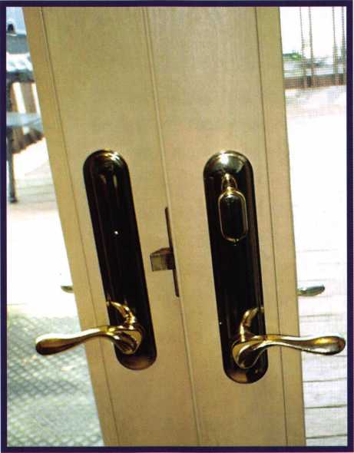

A look at the Peachtree interior trim.

First, let’s take a good long look at the Peachtree door. If  
you encounter one in the field that needs any sort of serv-  
ice, call for backup. In order to disassemble this door, it  
has to come off of the hinges. Sure, I can take one down  
by myself, but my rather slight build makes it difficult to  
hold the door in place when I’m putting it back up, trying  
to realign the hinge screw holes and hold the screwgun all  
at once. Its much easier with two people. Once the door

is down, remove the handle

and lock trim, and gently pry  
the sweep part way back to  
reveal the hole which runs the  
length of the door. Pull the  
faceplates off the mortise body  
and the upper and lower mod-  
ules, and run to the van for  
more tools.

A few unusual tools are  
required: forceps, a 3/32”  
alien wrench, and two “align-  
ment keys”, which are invari-  
ably supplied by Peachtree any  
time they send out parts. My  
advice to you is to either use  
these as ornaments on the  
shop Christmas tree, or to give  
them to any passing punk that  
you see on the street for use as  
decorative earrings. The align-  
ment keys fit so snugly in  
their alignment slots that you  
will spend a great deal of time

grunting, groaning and cursing quietly. Use a slightly  
thinner piece of spring steel, or my favorite tool... a pick  
with the tip broke off. It s amazing how much simpler  
the job will become.

If you can manage, watch the factory video before you arrive on the job. Its no shame to admit to your cus­tomer that you aren’t too familiar with the product, or that you service it rarely. Although the production value is almost humorous at times, the information contained in the video is important.

Keynotes • September 2004

To contact Peachtree, dial 1-888-

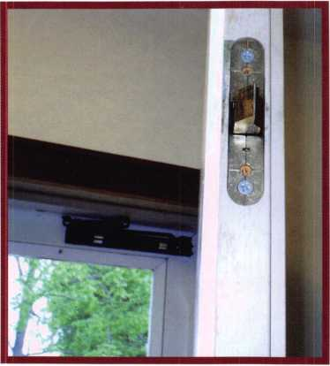

The Peachtree upper locking module.

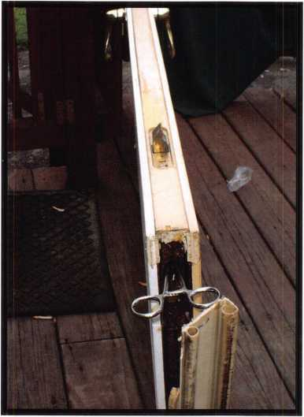

Peachtree door with forceps  
attached to the lower locking bar.

interior locki^Q P°

Once you’ve watched the video, you  
will probably be convinced that the  
locking bars in the door are probably  
bent. Peachtree seems to think that  
this is a common problem, but I have  
never seen it. Invariably, I find two  
recurring problems: alignment with  
the strikes, (caused by settling or faulty  
installation) or collapsed springs in the  
modules and the mortise body. My  
most recent Peachtree job was a combi-  
nation of both of these problems. The  
springs on this ten-year-old door failed  
to extend the modules far enough to  
allow the mortise body to turn to the  
locked position, even after replacing  
the entire mortise body assembly. In  
addition, the customer’s aggressive  
attempts to lock the door resulted in  
broken pieces in the upper module,  
which evidently wasn’t really properly  
aligned with the strike even when it  
was installed. A shim beneath the  
lower hinge of the stationary door  
managed to correct this

problem... one

we didn’t  
even

Keynotes • September 2004

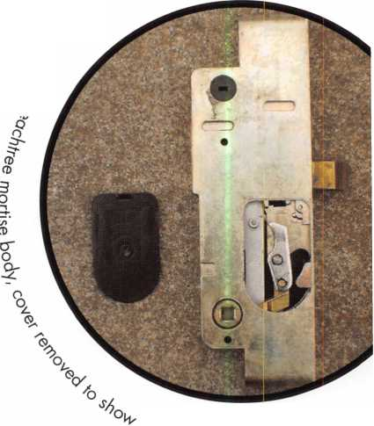

notice until virtually every piece of hardware had been replaced in the door! If the door locks and unlocks prop­erly when it is open, look to the alignment and strikes for clues that will help you remedy the situation.

The Peachtree door in the photographs had been installed over ten years previously. Still, Peachtree sent out parts to my customer at no charge. The customer was pleased, and more than happy to pay us for our time. We all know that a happy customer inevitably becomes a repeat customer!

One final note about the Peachtree doors... save yourself some embarrassment! The upper and lower modules con­sist of parts that are virtually interchangeable. If you remove this parts, take note that the word “up” is clearly printed on these. (OOPS.) The locking bars won’t EVER align if you’ve inverted these parts. In addition, the lock­ing bars are clearly labeled “T” for top and “B” for bottom. Other than that, everything you need to know is in the video, so there is no need for me to reiterate and regurgi­tate information which you can obtain elsewhere.

To contact Peachtree, dial l-888-Peach99.

The Andersen 3-point locking door is similar, but an entire­ly different animal to work on. Your first incentive to swear is the alien screw which attaches the lever to the door. This must be removed for even the most menial of tasks, includ­ing rekeying. Once you’ve gone through all of your SAE alien wrenches, go out and get a 2.5mm alien wrench!

Now you can remove the interior trim, the two phillips

head screws, and remove the cylinder for rekeying. Andersen invariably uses cylinders in a Schlage “C” keyway.

One of the most common things I’ve seen with the Andersen door is that the alien screw will be missing from either the interior or exterior lever... or both! The threads are the same as most “break-to-length” rim cylinder screws. If you thread the rim cylinder screw into the lever and break it off, you can then take a small file or dremel tool and cut a slot in it. This makes a quick and easy fix in the field, and the short end of the rim cylinder mounting screw is nearly the proper length, as well. Since both lever retaining screws are on the bottom, a little locktite or nail polish will insure that they don’t work loose.

The really nice thing about the Andersen door is that the entire 3-point mechanism is one piece, and can be removed without dropping the door. Simply remove the sixteen or so phillips head screws from the edge of the door, and the whole assembly can be gently pried away from the door. (Of course, the levers, trim, cylinder, and interior hub must be removed first, but beyond that, it’s a piece of cake.)

Andersen, (like Peachtree,) stands behind their product for 10 years on mechanical parts, so it is unlikely that your customer will have to pay for replacements. However, there are some “quirks” about dealing with Andersen directly, and it is best to inform your clientele of these before they place that important call.

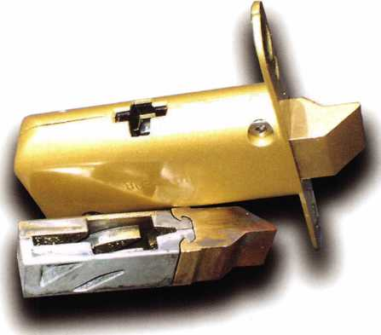

A new Peachtree module and  
the assembled parts which have been  
removed from the old module.

Keynotes • September 2004

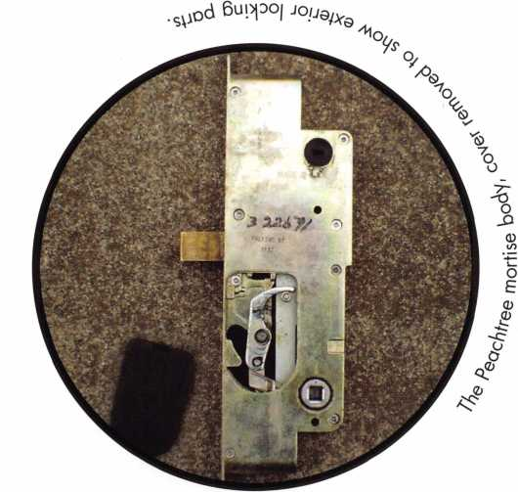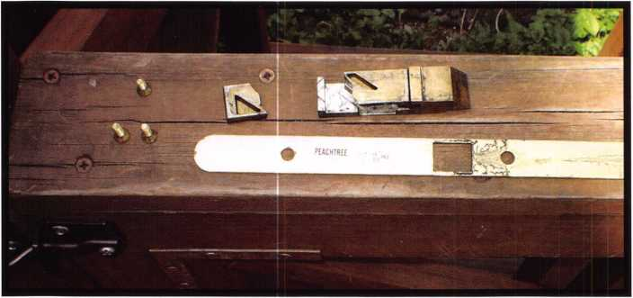

The mortise faceplate and the broken parts from

the upper control module.

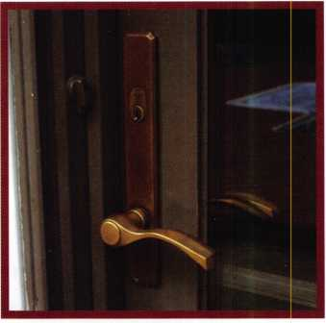

A look at the Andersen exterior trim.

**o\ o°eAev\ce-**

On any Andersen door, there is a “watermark-like” triangle in the corner of the insulated glass unit. It is hard to see, hard to read, and nearly impossible to photograph! The factory will want the series of numbers in and around this nebulous triangle to verify the date of manufacture of the door. (And you wonder why I leave this task to the customer? I’ve had enough trouble trying for two years adjust­ing to bifocals without squinting and trying to peer over the top! In addition, this triangle is usually in the top corner, somewhere around seven feet in height. Most customers are willing to jump through a few hoops for “free” parts, so let them squint instead!)

One exceptional feature of the Andersen door is the adjustable  
hinges. As it turns out, this is also something that I never knew  
existed until I was doing some work at a new construction site. The  
guy who was installing the door showed me that by adjusting the  
hinges, you can move the entire door up, down, in or out by simply  
making a few turns with an alien wrench!

Is this information top secret? It would almost seem so, but since  
alignment is crucial when there is more than one locking point on a  
door, I went out of my way to obtain detailed instructions. As it  
turns out, the information is readily available for download directly  
from the Andersen website, but finding it may take you through a

few wrong turns. Although the web-  
site is quite thorough and contains  
more information than you will prob-  
ably ever need, it is somewhat diffi-  
cult to circumnavigate. The file you

are looking for is “Hinge Replacement and Hinge

and Hardware Adjustment” for Andersen French wood  
Inswinging Hinged Patio Doors. If you don’t find it, don’t fret... I’ll  
give you a brief synopsis.

Andersen door with the  
interior trim removed.

The entire  
Andersen  
3-point  
assembly  
removed.

|  |  |
| --- | --- |
|  | 0 |
| —t-  u~ | O |
| CD | 0  D |
| > | —5 |
| 13 | Q |
| Q_ |  |
| 0 | 3 |
| CO | o |
| 0 | -1 |
| 13 | <o" |
| Q_ | 0 |
| 0 | CO |
| < | 0 |
| o’  0 | n  o' |
|  | D |
|  | o |

**8**

Keynotes • September 2004

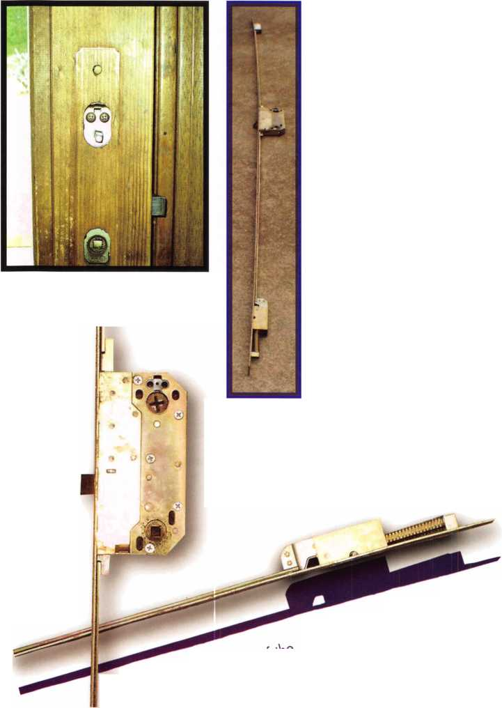

A 5/32” alien wrench is all that is required to adjust the hinges. On

the door side of the hinge, between the four phillips head screws,  
there are three alien screws. The outer two of these are position-  
fixing screws, which actually hold the two-piece hinge together.  
These must be loosened by a half turn before any adjustment is

made. The center screw adjusts the horizontal position of the  
hinge, tighten to pull the door closer to the frame, and loosen to

push it further from the frame. Remember to tighten your  
position fixing screws once you have made any adjustments.

The vertical-adjust-

ing screw  
is in the bot-  
tom of what  
we would  
normally

that safe techs are familiar  
with, since many safe hinges also have adjustment  
screws in this position. All hinges must be adjusted  
equally in 1/2 turn adjustments in order to distribute  
the weight of the door among the hinges. Most  
adjustments that will be needed will pertain to the  
horizontal alignment, due to door frame settling.

Andersen interior trim, showing the 2.5 mm alien screw

which secures the lever.

In conclusion, I am indebted to my good friends  
Bernie and Celeste Berkley, who allowed me to  
totally disassemble and photograph the compo-  
nents of their Andersen door for appar-

ently no good reason... the door was

functioning perfectly aside from

Bernie s attempt at securing the exteri-

or lever with a rather ugly bolt.

Further information on both of these

doors is available via contacting the  
respective manufacturer, so it is use-  
less and redundant for me to elabo-  
rate further when you can obtain  
detailed information elsewhere.

And the next time you see one of  
these beasts looming over you...  
don’t be afraid.... be informed!



Keynotes • September 2004

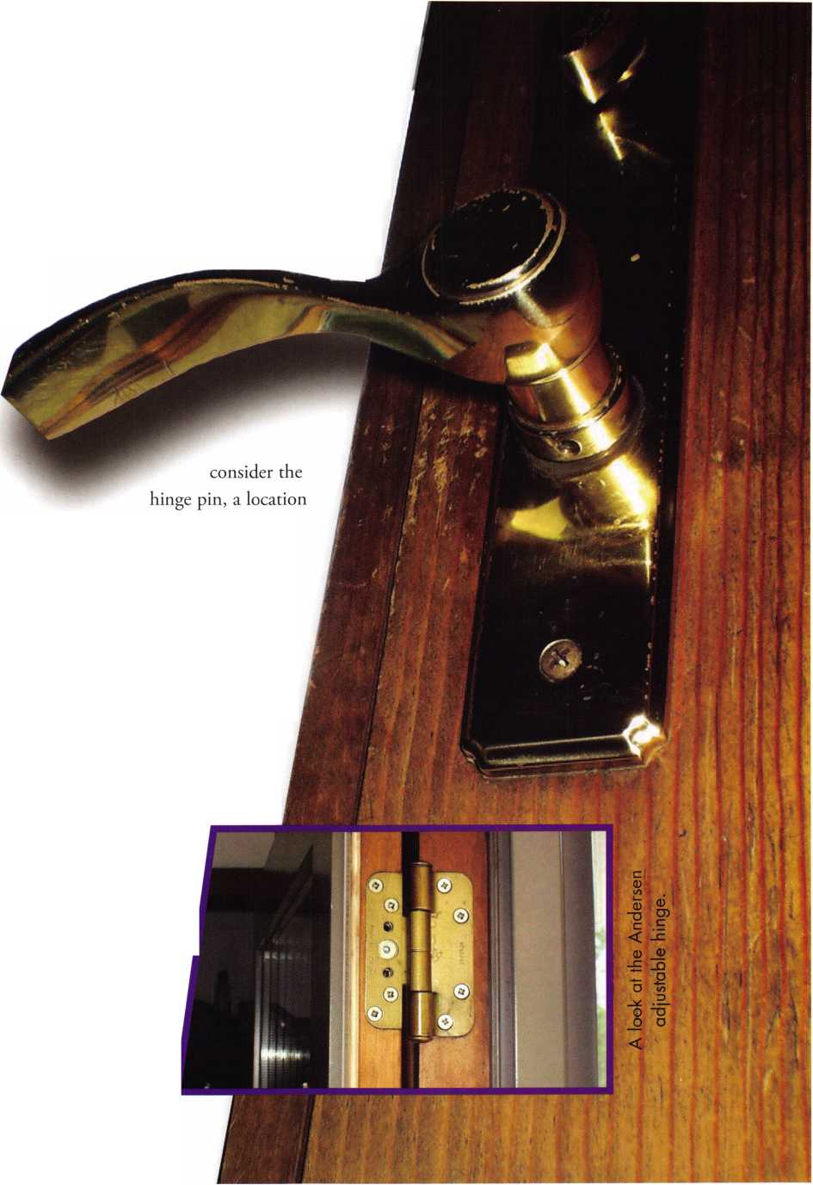

Bank Equipment Field Service

Combination Lock Manipulation

by Brian P. Smith

Over the years, one thing that has surprised me is the wide range of opinion used to define the term “manipulation” as it relates to combination locks. Some guys will go out on a call, and return telling me all about a “lock manipula­tion” they had performed. When the story is told though, it's more likely something I would have called a recovery from a mechanical or operator failure. The combination is still known but the dial ring may have been loose, a change wheel may have slipped, a spline key may have fallen out, the lubrication may have dried up, or the operator may have been improperly instructed on how to open the lock. This is not to say that fixing any of these problems is less important or honorable a duty. Just that it isn't what I have come to know as true manipulation.

True manipulation of combination locks is the successful determination of a combination through general knowl­edge of how the lock works and specific knowledge of how that particular lock responds. The manipulator with the capacity to master these skills is defeated only by mechani­cal failure. Manipulation is my method of choice. It isn't mystical. It really isn't hard. It is a matter of knowing the enemy and beating it at its own game.

My first encounter with combination lock manipulation was long before entering the profession. My brother had returned from his first year with the Marines on leave in 1969; I was 10 years old. Somewhere along his journey he had picked up the art of manipulating padlocks. The entire time he was home, he had that lock in his hand tinkering with it. The day it popped open he was so happy and he took the time to show me how he had done it.

I caught on pretty quick and after he had gone, I opened a couple of them myself before the thrill wore off and some­thing new took my attention. Thirteen years passed before I picked up another lock. During that time I had discov­ered the truth of the axiom that every chain is only as strong as its weakest link. I had experienced several thefts

and acts of vandalism in which the locks involved were completely avoided. They had little or no deterrent value. Even in my line of work at that time, as a Toolroom Machinist, I realized the futility of locking things up. It was obvious that these locks served as little more than a sign asking the honest to stay away, and the dishonest (who generally prefer to be referred to as fun-loving joke- sters) to grab a crowbar and help themselves.

About the same time I was ready to give up on all locks and locking devices, I was introduced to the world of bank equipment. It appeared to be the really serious stuff, and the kind you don't see just anywhere. And if that wasn’t enough, there were the jewelers’ safes. With those, there was little doubt that the lock is indeed the weakest link, but weak is a generous term to be spoken of and is only relatively to the strength of the overall unit.

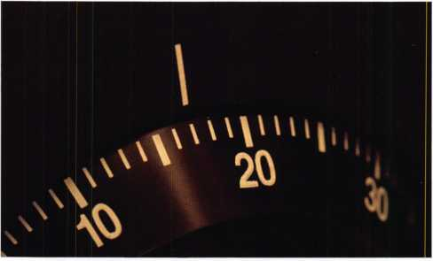

To me, the practice is just like that of keylock picking without the benefit of actual direct contact with the parts involved. There is no preconceived damage, simply the need or desire to enter without the generally accepted tool: the key or combination. I have found that even with train­ing (which is essential) and practice with a lock set up on a stand (which is not always convenient); nothing prepares you for the real thing like the real thing.

Keynotes • September 2004

My training was under the instruction of a man named Rex Parmalee. He gave (for a substantial fee) a weekend seminar here in St. Louis back in 1992 under the company name of Security Plus. It was in a hotel conference room where we spent the first day going over general lock and safe identifi­cation and maintenance. The next day was a non-stop manipulation course in which he explained and demonstrat­ed the process. At the end he set us all to time trials to see who would finish first. My employer and myself were the first out of a class of about one hundred. We were feeling pretty special, but you must understand these were LaGard key change models... not the toughest, especially after hours of practice. But we had a good lesson and were ready for action.

Since then I have had many opportunities to open security containers. I have had many successes and some failures as well. No safe has beaten me yet. Whether floor safes or vault doors, one way or another I get in but manipulation really has its time and place. There are times when the customer just doesn’t have faith in the practice. They would rather see action. It doesn't matter to them that this could end up costing them much less in time, parts and repairs from a drill job. They want to see metal fly, sweat drip, and an open door. If quick access is all they are interested in and they don't need to use the safe again right away, then drill it.

But if it is an antique safe of value, or they have are not willing to take the risk of not using the safe immediately afterward; manipulate.

For those times when the conditions are right, manipulation is definitely the way to go. From the calls that include peo­ple having changed their own combination and don't know what they set, to the ones where safes or vaults have been abandoned long enough for the combinations to have been lost of forgotten, I would much rather spend a little more time in one trip of manipulating. I carry only a flashlight, a pencil, and a can of spray oil. That's it.

Compare that to dragging in a drill, an extension cord, a pressure rig, carbide and high speed bits, magnets, mirrors, borescope, and your lucky toolbox. Then there are the dashed hopes of finding an electrical outlet nearby, worrying about causing damage to the customers possessions (the safes contents), and hoping for a clean shot the first time. This could go late. And then you need a dolly to carry the safe

door out to the truck, or you must carry in a welder, hammer, pins, maybe a lock, dial and accessories, protective gear; never mind the body filler and touch up paint, brushes, pans, thin- ners, rags, and all the stuff you should have brought but forgot. I think you get the picture.

If it gets late while manipulating, I throw the flashlight and pencil in my pocket, fill one hand with the spray oil, shake the clients hand with the other, and I'm off 'til tomorrow.

Now. As for those automatic dialing rigs, let's just say the jury is still out. I have used them. I have watched them work, and while they do work sometimes, other times they fail. They take too long, and even cause damage. I have out- manipulated them because I have something they lack: a memory of what looked like a good number even though it was not a clear hit.

There is one thing about them that I see as a real asset.

As long as they are working, the benefit is the prospect of being able to walk away and concentrate on something else while they run through their routine. But the problems start when you return to find it still grunting away. Upon closer inspection you find that the spindle has seized up and the chuck is slipping or worse. It has taken the dial with it. LaGard locks are great for that. The machine reads “DIAL­ING COMPLETE”; so you take off the rig and the dial comes off with it!!! And no, it is NOT open.

The model one of our technicians owns (pretty standard construction I would say) is built too light duty. It looks good in the box, but as it is set up, its weakness shows.

It has three-quarter-inch diameter aluminum rods which support the dialing head from the base. The base attaches with magnets to the safe door. These are sufficient for a lock operating smoothly, but this is not always the case.

It is especially a problem when the rig is left unattended; the only time it is really useful. The repeated vibration and twisting action are often too much. It can and does become loose and misaligned, causing errors in the process.

It is also difficult to set up because of the mere fact that this machine does not have the ability to deduce the drop point gate spread. This is an integral part of the manipulation process which must be made up for by trying every possible combination. Sure it works, but a lock is not made to with­stand this kind of constant dialing. Remember friction? It can and does do horrible things to mechanisms without enough lubrication.

21

Keynotes • September 2004

I admit to not knowing all of the technical data used to deter­mine how many turns a dial can endure before freeze-up, but I guarantee you that frequency of use is factored into the equation when locks are designed and lubricated. Relentless dialing for hours on end by a manipulation machine is not considered in that calculation.

All things considered, manipulation beats all of the safe open­ing alternatives. I wouldn't begin to attempt a lesson here. There are lots of courses available out there. But I do offer a few pointers.

For me, the concentration is a problem. Any questions or comments from the peanut gallery throw me off. If you are the same way let your audience weigh the costs for themselves. I explain to them up front (tactfully of course) that the work is by the hour and I take less time if I'm not talking. They usually understand and scurry off telling me where they'll be. The other thing: observation is critical. Once you have your solitude, focus on the safe. Hear everything it does. Feel the sound through the sides with one hand and dial with the other. Watch everything. If you see the slightest change in the alignment of the index and the dial marks, take note of it.

Remember that each change is relative to your connection to the inside. The spindle may be bent, the wheels are not per­fectly round or there may be slack in the spline key. If you need glasses, use them. Eye strain is a potential problem. Tike time to rest your eyes if needed.

When you feel like you have been there too long, you have been there too long. Hike out and get the drill rig. But if you feel like you are in this one, but your concentration is weaken­ing, your eyes are straining, and everyone has a question that only you can answer; take a break from it. That doesn't mean stand back and stare at it. This only continues your frustra­tion. It means go answer those questions. Finish up some paperwork you may be behind on. Straighten up your truck supplies. Whatever it takes to make you forget about it for a while. Take just long enough that you start feeling confident about the job again. It gives your mind time to sort out the details, and soon you will be back with new determination.

Lock manipulation is a matter of mathematical and physical reality, but it is equally a matter of extending your senses. If you can make the parts inside of that lock an extension of your self, you can open it. That is your advantage.

Just call 310-575-5074 and receive:

**1.**

2.

3.

4.

5.

6.

7.

8.

9.

1. 11. 12.

13.

14.

15.

16.

17.

18.

19.

1. 21. 22.

ALOA Index of Documents

Becoming a Locksmith (Ipg)

Locksmith Career Summary (3pg)

Locksmith School List (2pg)

ACE Class Schedule (8pg)

Certification lnformation(3pg)

PRP Category List (Ipg)

ALOA Membership Application(2pg)

ALOA List of Benefits (Ipg)

Scholarship Application Form (Ipg)

ALOA Video Library Order Form (Ipg)

ALOA Membership Items Order Form (Ipg)  
Safe & Vault Technicians Association Member  
Application/Subscription Form (2pg)

ALOA Chapter Roster (3pg)

Legislative Action Network (2pg)

Legislative Action Network Newsletters (Ipg)  
Various State Laws (lOpg)

Industry Position Pager (Ipg)

Current Legislative Action Network  
Newsletters (Ipg)

Board of Directors Nomination Form (2pg)  
ALOA Convention Registration  
ALOA Board Expense Reimbursement &  
Request Form

Keynotes • September 2004

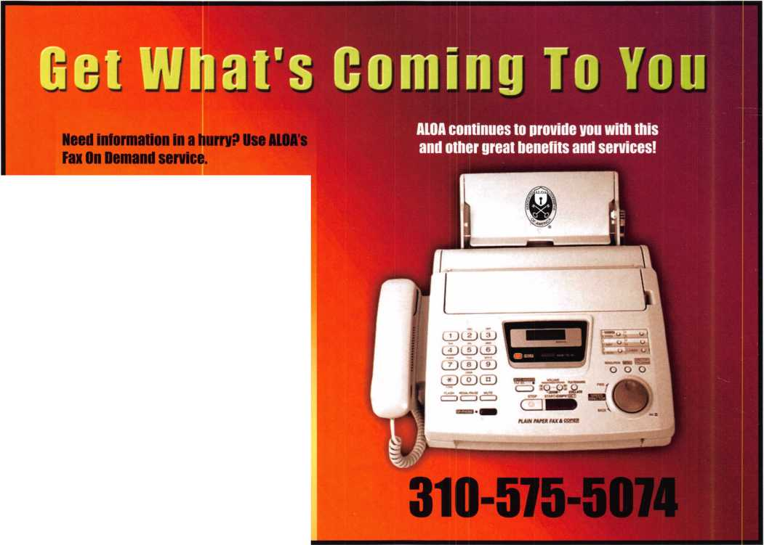

**core**

Southern Steel/Folger Adam Merger

Phelps Tointon, Inc., Southern Steel's parent company, completed the acquisition of the principal operating assets and business of Folger Adam Security, Inc. on August 9, 2004. This acquisition brings together two of the pioneer manufactur­ers of detention products into the United States: Folger Adam established in 1905 and Southern Steel in 1 897—a total of over two centuries of experience.

The new name for the Folger Adam and Southern Steel Company will be Southern Folger Detention Equipment. The Folger Adam product line will remain viable and active to satisfy both the needs of replacement parts for Folger's facility base, as wells as the new construction market. Over the next eight months, the Folger Adam product line will be moved from Lemont, Illinois to San Antonio, Texas. To maintain the quality and workmanship that the name Folger Adam has meant to the deten­tion industry over the past 100 years, this move will be executed in three well- planned phases: the first is to develop written and video recorded assembly instruc­tions for all Folger Adam products. During the second phase, a sampling of the Folger Adam product will be built in San Antonio. The final phase will be the actu­al move of documentation, equipment and fixtures to San Antonio.

New and Improved Website at LAGARD.COM

LA GARD is pleased to announce the launch of a new website at [www.lagard.com](http://www.lagard.com). The time was certainly right to upgrade the old site and introduce a new-and-improved look that we feel will reflect our enthusiasm and our mind-set for the upcoming years. The ease at which the user will be able to navigate around this site will be a great time saving and beneficial fea­ture that we hope will entice the customer to re-visit LA GARD.com time and time again. "With so many new innovations coming to market, timing couldn't be bet­ter to introduce a state-of-the art web-page to fully showcase all of our products with such ease" said Susan Papa, Vice President of Sales and Marketing for LA GARD.

The new lagard.com enables the user to find the answers to the most asked ques­tions about each and every product offered by LA GARD, along with cutsheets which entail specifications and features of each product available to download with a click of the mouse. Lagard.com also features an up-to-date International and Domestic Distributor list for customers all over the world.

In Memory

ALOA member Richard Walther passed away this month. A locksmith for over 35 years, he is described as being dedicated to his work. His mother, Norma Walther stated, "His whole life was his business and when he said he provided 24-hour service, he meant it! It was not unusual for Richard to take calls in the middle of the night as he was the only locksmith in Waverly, Iowa." Richard Walther attended ALOA conventions and classes and was known to many as a dedicated professional and a friend. Richard started his working career as a farmer, growing corn, soybeans and oats. Locksmithing was "just a hobby" in the beginning but soon took over farming as Richard's main interest.

Locksmith Killed at Work

Client was a Victim of Earlier Crime

by Allen Lengel, Washington Post Staff Writer

A young immigrant locksmith was fatally shot in Southeast Washington as he tried to help a robbery victim get into his car after the keys had been stolen.

Ehud Raich, 25, was assisting the car owner when a gunman approached on foot and fired once, striking Raich in the neck, police said. The shooter then jumped into a dark-colored car occupied by one person and fled.

Raich, an Israeli native who lived in Arlington, was pronounced dead less than an hour later.

For the complete story, visit <http://www.washingtonpost.com>.

"Locks & Locksmiths" Yellow Pages Heading Generates More Than 32 Million Look-ups Per Year

Whether responding to a family locked out of its car or changing the locks on a new home or office, locksmiths are crucial for both emergencies and everyday security services. According to the Yellow Pages Integrated Media Association® (Yellow Pages I.M.A.®), 3.5 million Americans refer to the Yellow Pages annually to search for a locksmith, generating more than 32 million look-ups per year.

For more information on specific Yellow Pages headings, please visit the Yellow Pages I.M.A. Web site at <http://www.yellowpagesima.org/research/index.cfm>.

S&G Factory Tours

Sargent & Greenleaf, located in Nicholasville, Kentucky, has begun a regular schedule of factory tours. Two tours will be conducted every Wednesday, at 10 am and 2 pm. There is no charge for the program, but space must be reserved in advance. This can be done by contacting Emma Davis, at 800-826- 7652, extension 216. Each program will last approximately 40 minutes.

P.O.L.A. Celebrates 40 Years

The Penn-Ohio Locksmiths Association will be observing its 40-year anniversary this month. In 1964, Paul Kirchbaum, a former director of ALOA invited lock­smiths in and around the Youngstown, Ohio area to meet with him in his shop to discuss the possibility of forming a local locksmith's association. The purpose was to further education and foster fellowship among locksmiths as wells as to show­case manufacturer's products to the group. For information on activities and mem­bership, contact P.O.L.A. at 724-962-2127.

Editorial Correction

In the June 2004 Keynotes article, Spherical Masterkeying by Eric Costley, CRL, key #16 is missing from the text. The key is gBCDkF.

NEW CERTIFICATIONS

CMLS

CURRY, AUSTIN R.  
GALLAGHER, JOSEPH  
LAEGELER, GEORGE  
MARCUS, HARRY F

CPLS

BALDWIN, JEFFREY G  
MATTESON, JACOB B  
BROCKNER, JOHN D.  
CHAMLEE, JAY R.  
CYREE, CHRIS W  
GRUBER, JAMES E.  
MONROE, MATTHEU  
WIEDMAN, JAMES W.

CRLS

BIERMAN, TERRY L  
BLYSTONE, BRIAN R  
CAMPBELL, BRUCE A  
CLAAR, DAVID E

CLIBER, JOHN A.

COX, JEDDJ DEMUTH, LAWRENCE FRIEDENBERGER, WILLIAM R FORSON, WILLIAM KINDRED, WILLIAM J. LEE, ROBERT PAULOS, TEDDY S PETERSEN, MICHAEL REX, TERRY SMITH, ROBERT W. SNOOK, HARRY G. SNYDER, DEBORAH S. STRACKE, CHARLES D. STRAUSS, CHRIS TRUEMPY, JOHN D. WILLIAMS, SCOTT WILSON, NICK R.

BROWN, DANIEL M. CAJIGAS, ALEJANDRO CARTER, JOSEPH DEVOTO, ANDREW J EVANS, DEAN LEE FRANKLIN, WILLIAM B. NEJELSKI, STEPHEN D. RIDEN, STANLEY TIMCHAK, GARY G. WALKER, ANDREW D WOMACK, WESLEY A

CPS

BILLHEIMER, DAN DUNN, JOHN III HAWK, PAUL SELLERS, EDWARD

Now you can have

your Security and

meet Life Safety Codes

Too! Locks are designed to

help keep the bad guys out.

Codes are generally written to let

out. Safety versus security—

they often clash. Federal government

standards, commonly referred to

as GSA standards, for storage

of classified materials requires

a lock approved under federal

standard FFL-2740.

Currently, the only locks  
approved are the Kaba  
Mas X-07, X-08, and  
X-09. The X-09 is the  
only lock currently  
being manufactured.

If you need to install  
the lock on a personnel  
door the requirement  
comes from FFL-2890.

Until Lockmasters devel-

oped the LKM7000 series of  
locks the only approved locks  
were the CD or Combination  
Deadbolt versions  
of Kaba Mas X-07, 8, or 9

A couple of problems exist with using a CD lock. First, life safety codes require single-motion egress. If you have a locked CD lock, two hands are required to open the door. One to turn and hold the small knob on the CD lock and a second hand to turn the doorknob. The second issue is the Americans with Disabilities Act or ADA. The small knob on the inside of the CD lock has never met the requirements for lever or paddle for egress. Third, in the case of federal

government facilities and perhaps others, a variance is  
allowed to use the CD lock, provided the life safety button  
is pushed in while the building is occupied. This requires  
the first person entering the building to dial the combina-  
tion of the lock from the outside of the door then push the  
button in thus blocking the dial from being turned. At the  
end of the day the last person out of the building is required  
to go back to all the doors and release the life  
safety button then turn the dial on

the outside of the door to lock  
the CD lock. The problem  
is in most cases either

the CD lock is not  
unlocked during  
the day (bad for  
life safety) or the  
door is not  
locked at night  
(bad for securi-  
ty)*

Lockmasters  
solved all these  
issues and more

with the LKM7000  
family of locks. The lock

starts as model LKM7000  
(Add the LKM7001 key override

module

and it becomes model LKM7003.) Additional variations  
are available such as the LKM70001 exit device (no out-  
side trim) or it is available in a package with an X-09 lock.  
The LKM7000 works on both inswing and outswing  
doors with no modification. The only difference is the  
choice of strike. Let’s look at how they solved each issue  
and we will install a LKM7003 lock on a door.

The first issue is life safety. The LKM7000 always allows  
egress. The locking mechanism only prevents entry. The

The LKM 7000

by Greg Perry, CML, CPS



Keynotes • September 2004



second issue, since the lock use a lever from the outside  
and a push or pull handle on the inside, it meets ADA.

The third issue regarding leaving the door locked or  
unlocked at the wrong time is solved in a couple of ways.  
First, since the lock always allows egress, there is no need  
to unlock and push in the life safety button or for the last  
person out to relock the lock. Next the LKM7000 has two  
bolt position monitor switches. We can now tie the switch-  
es into the alarm system. This means we can electrically  
monitor both the deadbolt trigger and the bolt position of  
the combination lock. Between the two switches we could  
prevent arming of the alarm system unless the locks are  
locked. Security officers should be happy with this feature.  
Lockmasters will soon be submitting the LKM7000 to UL  
for testing on a fire-rated door. The hope is to receive a  
20-minute listing, the same as the Kaba Mas CD locks.

Typically the combination lock installed in the LKM7000  
will be a Kaba Mas X-09 although any “standard” footprint  
combination lock can be used, provided it meets the  
requirements. This means if you do not have the need for a  
lock meeting the GSA standards, the LKM7000 can use a  
mechanical lock. If someone else should design a lock meet-  
ing the requirements for FFL2740 it could also be used.

The LKM7000 has another feature to make it even more  
appealing after the combination lock is unlocked. Inside  
the base unit is a solenoid module. This module allows the  
LKM7000 to be released electrically using either 12 or 24  
volts. This means, in the most basic form, that it includes  
a remote release switch with a power supply. In the more  
advanced form we can release the lock from the outside

using electronic access  
control. This negates the  
need for

a separate lock and electric  
strike or magnetic lock. If  
the LKMOO1 key override  
module is installed, the  
solenoid is included in the

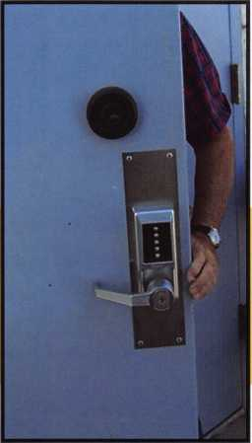

override module and the one in the base unit is either removed or disabled.

Opening the box for the first time can be a little intimidat­ing. The instruction manual looks like a small book. The lock is heavy and the templates might scare a few. This being said, Lockmaster has created a drilling fixture. And although the installation may take 9 to 10 hours the first time, especially with the plastic templates, the lock is not difficult to install. It is time consuming, but not overly dif­ficult. Its somewhat like a jigsaw puzzle. Most of us could not sit down and build a 1000 piece puzzle unless we start­ed with the easier 60 or 100-piece puzzles and worked our way up. If you follow directions and understand lock installation methods you should be able to install this lock. If you are early in your career or shy about a long installa­tion, I would not recommend attempting this install.

John Chaco, West Coast technical guru for Lockmasters, joined me and the two base locksmiths, Jim Crow and Chris White, to assist us with this first install. Before start­ing to install the LKM7000, all other locking systems must be removed from the door or better yet install a new door. The door we are installing originally had a mortise lock. Several years later, a Simplex/Unican LI021 lock was installed along with a Lockmasters LKM5001. This was the Lockmasters version of the CD-X07 lock. This door and installation is probably about the worst you might encounter in the field. Most doors will not require all of the repairs necessary on this one. Once these locks were removed the door was evaluated. A 12” x 16” plate was installed on each side of the door to cover all the old holes.

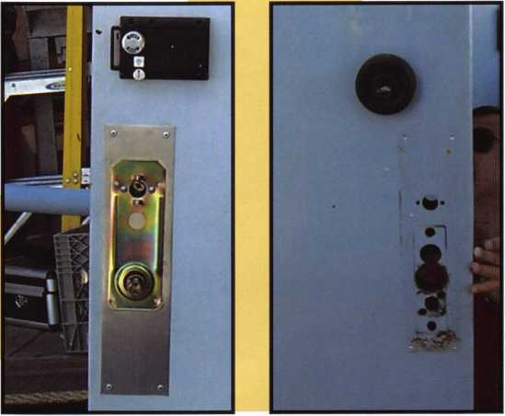

Keynotes • September 2004

Photo 4

The plates were  
offset slightly  
on opposite  
sides to proper-  
ly cover them.  
Next, the strike  
was moved  
down on the  
inactive door.  
We also cut the  
astragal for the  
loop of the lock  
so all the strike  
screws would be  
into the door  
and not the  
astragal. Only

We chose the fixture. The inside drill guide fix-  
ture was placed on the strike and the door was  
closed. A level was used and two screws were  
installed to hold the inside fixture in place.  
Alignment was check by opening the door and  
using the brass slide bolt to check locking. Once  
you are comfortable with the alignment drill the  
“A” 1 5/8” spindle hole and the 6 “B” 5/16”  
holes. Only drill these holes partially into the  
door. We chose not to drill the 4 “C” holes until  
after the lock was installed in case we needed to  
adjust the lock position slightly. Next, we  
installed the second portion of the inner fixture.  
This piece has two spindles on it to align the  
outer drill guide. We. installed the outer drill  
guide on these spindles and used the supplied

clamp to secure the two halves together. Then, we drilled  
the outer holes, “D” 3/4” and 6 each “E” 3/16”. Once all  
the holes were drilled the fixture was removed. (Some of  
the holes needed to be enlarged to their final dimensions.)  
Next, since we wanted to install the Key Override  
Cylinder Module, the plastic template was applied to the  
door. (Lockmasters is redesigning their fixture to add the  
key override module, but at this time only the plastic tem-  
plates are available for marking the correct locations on the  
door.) After completing the holes for the Key Override  
Module and drilling the balance of the holes to the correct  
sizes, the plates were removed and the holes and plates  
were deburred. Removing the plates also allowed us to  
clean all the loose metal shavings from under the plates.

We then reinstalled the plates. All of the drilling and  
cleanup required about two and one-half hours.

one screw was used to hold the strike in place  
until the lock was installed in case we needed to  
adjust the location slightly. The plastic template  
can be taped in place, or the drilling fixture  
Lockmasters created just for this lock can be used.  
Using the plastic templates requires a great deal of  
precise measuring. Both vertical and horizontal  
lines must be properly aligned on both sides of  
the door, not an easy task for many of us. John  
brought along his fixture and after looking at the  
plastic templates again we made a choice.

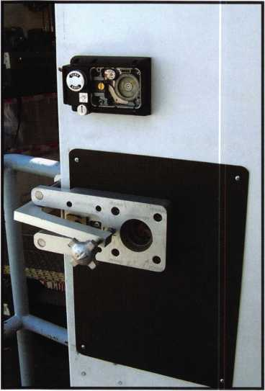

Photo 5



Keynotes • September 2004

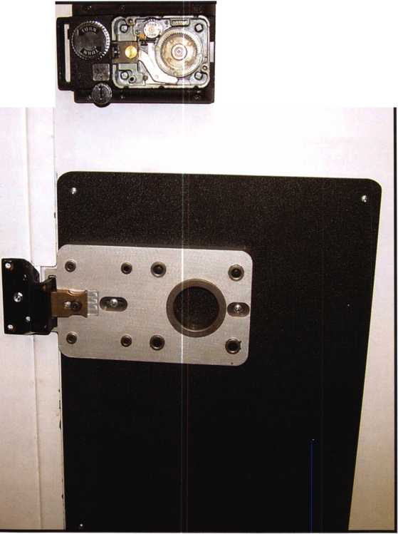

.. .Time  
consuming  
but not overly  
difficult. Its some-  
what like a jigsaw  
puzzle.

Then came the tricky part. The tailpiece  
from the cylinder, the light tube and the  
spindle tube all needed to align with the  
base unit as it was installed on the door.  
The front plate was installed on the  
tube, then the screws were installed.

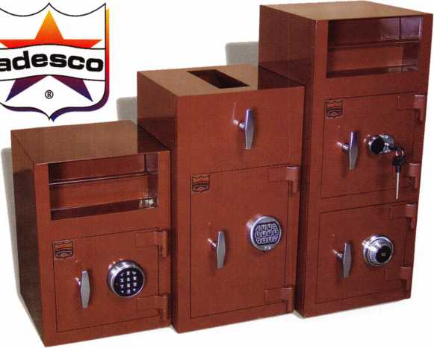

Finally it was time to install the lock. Since this we were  
installing on a hollow metal door, a thru-bolt kit warused to provide support of the lock. The kit was  
attached using Allen screws with a little Locktit  
threads. The outside lever was installed on the  
spindle. It was held in place with a socket head  
screw from the underside of the outer front plate  
bly. Since we were installing the key override cylindc  
the mounting plate from the underside of the front plate  
and the plastic filler from the appropri-

ate side were removed. Its not a bad idea  
to check the inside of this assembly to  
verify the timing marks are correct.

Next, we removed the inner cover of the  
base plate. The two halves were installed  
on the door using four socket head cap  
screws. On the outside of the door the  
spindle tube was marked below the sur-  
face of the outer face. Another method is  
to count the number of notches on the  
tube. In our case, five notches were  
placed at the end of the tube about 1/8”  
below the face. Lockmasters designed the  
lock to have about 1/4” of play or toler-  
ance. We also installed the key override  
plate and the cylinder. The lock was  
removed, and the snap ring holding the  
spindle tube was removed so it could be  
cut in a vise at the appropriate place.

The tube was deburred, cleaned and  
reinstalled on the base plate. The screws  
for the key override plate were installed  
and the light tube installed in the door.

The key override module was installed  
onto the base plate.

New from Adesco.

The Latest Technology

aft Affordable Prices!

**Special Introductory Pricing and  
Promotions Available Now.**

Introducing the all new Business Deposit Safes from  
Adesco. Safes feature precision plasma cut doors and  
solid 1/2" monoframe faceplates. Door jams are reinforced  
and tied to safe sides. Postal drops offer our famous  
recessed baffle technology. *LaGard’s all new Group 2M

combination locks and spy-proof dials included  
at no additional cost. All these features  
and more at an economy price!

Call your Adesco distributor today.

*When available

(800) 694-9340 • [www.adesco.com](http://www.adesco.com) • [safes@adesco.com](mailto:safes@adesco.com)

Keynotes • September 2004

**2**

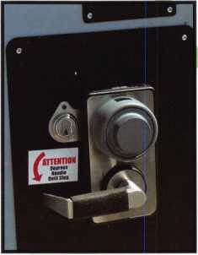

Photo 10

Photo 1 1

Photo 1 2

Photo 1 3

This lock was mounted too high to be covered by the lower plates. Lockmasters redesigned the strikes for adjustment. The center screw hole was enlarged to allow for fine adjustment. There were also shims provided for moving the strike away from the surface. The only down­side to these strikes is they changed the screw locations. This can be a blessing if you only need to move the strike a little and need new screw holes, or a little bit of a curse if you don’t have the same strike.

Installing this lock required over five hours of labor, and  
we had some of the best help in the industry. We also had  
the Lockmasters drill fixture to help us. We did not pro-  
vide any of the wiring for the alarm system or electronic  
access control system which saved time as well. With  
wiring and door coring it could easily have taken eight  
hours or more. This was a fun, although long install. Most  
locks don’t take this long to install. However, after learning  
the art of installing this lock, the hard work can quickly  
turn into a very profitable endeavor.

Once again, the alignment was checked and we adjusted the lock and strike slightly for better operation. The four screw holes we didn’t drill earlier were drilled and installed with the balance of the strike screws. Again operation and alignment were checked.

then, it was time to install the combination lock. We installed a Kaba Mas X-09, although we could have reused the X-07 portion of the lock from the original LKM5100. This would have required several new parts: spindle, dial, hub, tubes and bolt. The customer opted for the new lock. The X-09 install requires a separate article so I won’t cover the steps here. After the lock was installed the back cover was installed and we were left with tool and area cleanup.

Lockmasters has developed a number of plates to help  
with the install. Three of them were used on this install.  
The first was used to cover all the original holes from the

original locks. The next two plates were installed over the  
original holes from the CD lock.



Keynotes • September 2004

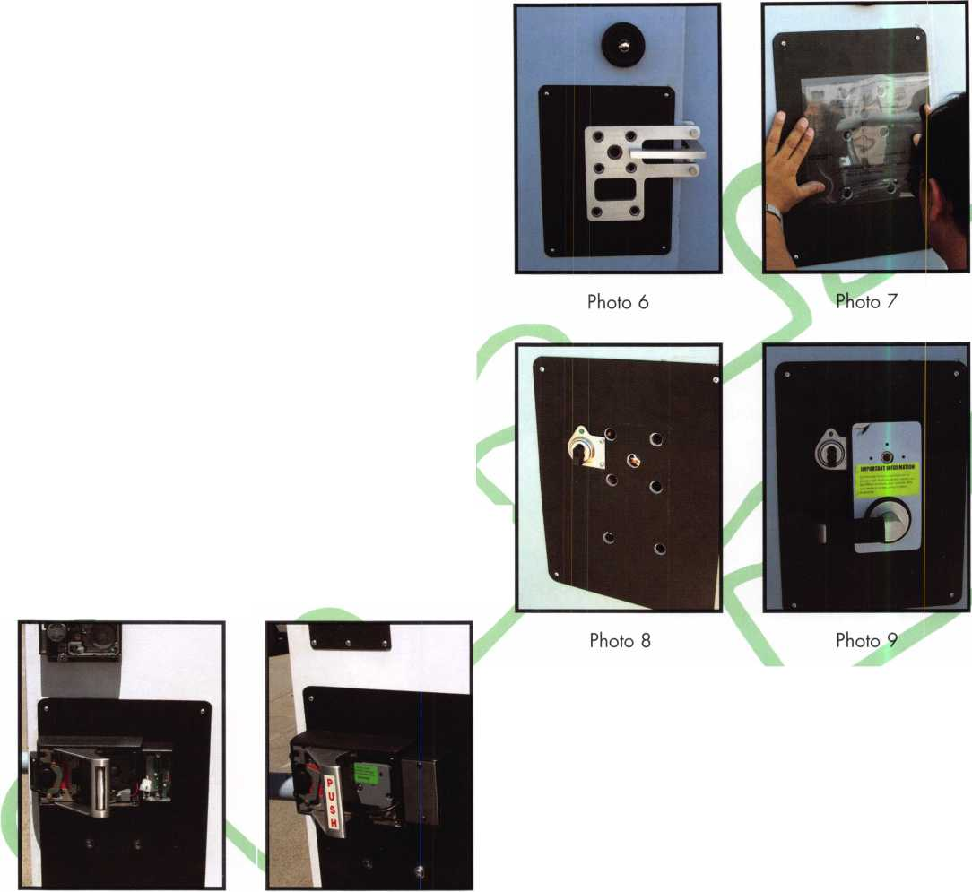

The LKM7000 lock is interesting. It truly fills the gap between safety and security. Meeting life safety and security in one package is something others have tried before but have not been able to obtain with a security blessing from the GSA. The federal government allows for variance of the codes. Often the fire marshall or safety inspector is overruled by the security requirements on federal properties. They are willing to accept two locks on an exit door. The government contractor, on the other hand, must live by the more stringent codes and cannot have two locks on exit doors. This lock solves the problem. I’m cer­tain as time goes on and the federal inspectors, both safety and security, see the LKM7000. It will become the only door lock used for securing our government secrets.

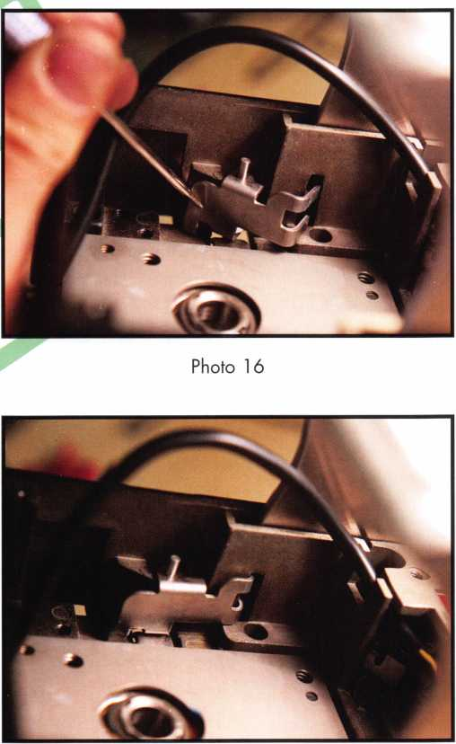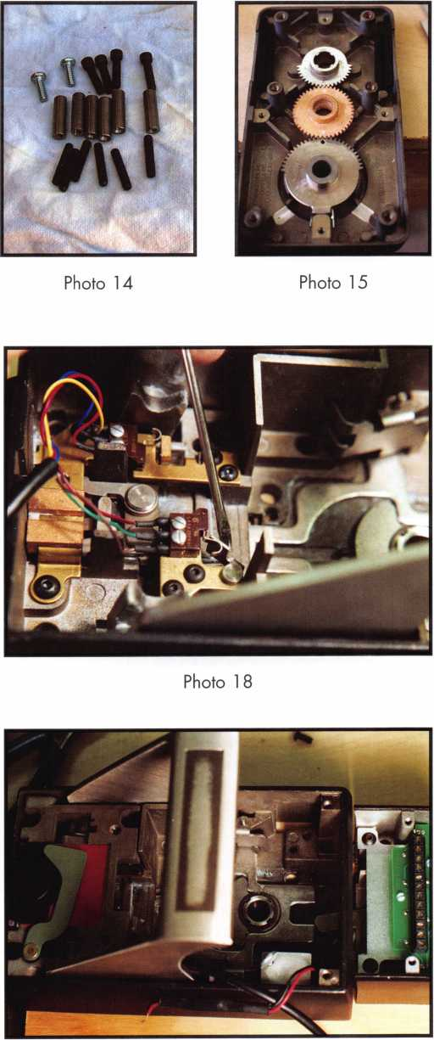

Photo 19

Photo 17

Keynotes • September 2004

Opening Day at the ALOA Security Expo

by Claire L. Cohen, CML

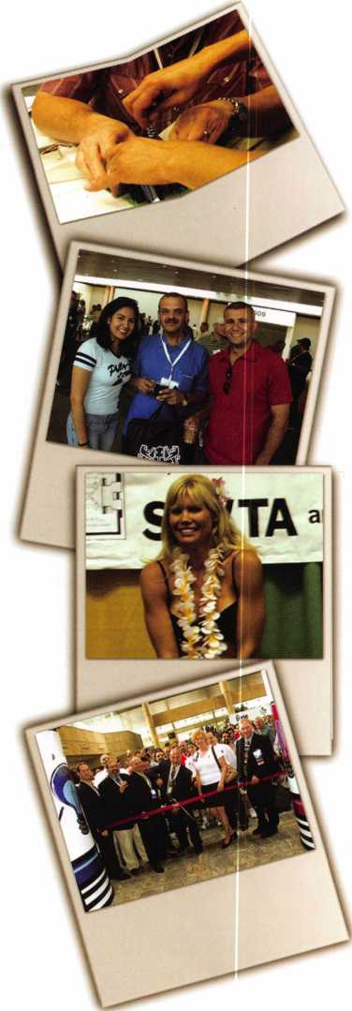

A crowd had already started gathering near the registra­tion area around 8:00 a.m. on the opening day of the 2004 ALOA Convention and Security Expo. Eager to begin the days activities, those who had come to Baltimore want­ed to waste no time waiting in line. Next to the registra­tion booth, ALOA volunteers handed out ribbons and the 2004 ALOA lapel pin to adorn name badges. Who would have the most ribbons hanging from their name badge today?

Standing in the huge lobby of the Baltimore Convention Center, ALOA members from all over the world con­verged. “How have you been?” “Glad to see you!” could be heard echoing the halls. Fellow convention attendees from years gone by were anx­ious to renew acquaintance. A long-time ALOA member summed it up by saying, “although you may not have talked to someone for a cou­ple of years, when you see them at the ALOA conven­tion, you pick up your con­versation as though you saw them last week.”

For some, this was their first ALOA Convention. Other seasoned veterans, proud of their past attendance, wore hats, vests or shirts decorated by label pins souvenirs from past Conventions.

The CML and Keynotes Breakfast was about to begin. Sitting at round tables, mem­bers quickly introduced themselves. The invitation- only breakfast was conducted by David Lowell, CML, CMST. A very informative meeting included statistics on PRP certifications as well as a discussion of plans for the future of the program.

Bruce Carey, CML, CPS, a locksmith from northeast Pennsylvania, had come to the CML Breakfast enthusi­astic about a class he had just completed the day before. The class, Advanced Masterkeying, was taught by Jerome Andrews, CML. Prior to attending the ALOA con­vention, Bruce had been chal­lenged by a Pennsylvania school system to solve a mas- terkey problem. The school was using large format Russwin high security locks.

Keynotes • September 2004

VIEW the entire collection of ALOA 2004 Convention and Security Expo PHOTOS online at [www.aloa.org](http://www.aloa.org)

vention floor was flooded with enthusiastic locksmiths looking and listening at each booth. Quickly everyone was seeing new products, learning about their applications, and asking questions.

As the future of locksmithing extended before the eyes, we were showered with new tools, new electronics, advanced software, innova­tions in safes, and a multi­tude of unique ideas brought to us by the experts in our industry. Bags were begin­ning to fill up quickly, as everyone checked out each booth and picked up litera­ture, catalogs on CD and product samples. Who could resist all of the “freebies”, entering to win door prizes and take advantage of show discounts? And this was only the first day and the begin­ning of the show. Two more days of trade show would give everyone an opportunity to see “the best of the best” in the locksmithing industry!

Time went by quickly, and was on to the ALOA mem­bership meeting. Goals for the future were announced and individuals were recog­nized for their outstanding achievements. This meeting gave members an opportuni­ty to speak about their con­cerns before the entire mem­bership.

With just a few minutes left until the start of the 2004 Security Expo, the lobby was a sea of locksmiths. The industry’s biggest and best show about was to begin. Waiting to go into the huge exhibit area, all in attendance were anxious to see hundreds of exhibitors who would be showing their latest product innovations.

Finally, the awaited moment and the ribbon cutting for ALOA-2004! With large cloth bags in hand, the con-

During the class, Bruce dis­covered the solution to the school problem! Now armed with more education and a good solution, he would be able to help his customer when he returned home.

Keynotes • September 2004

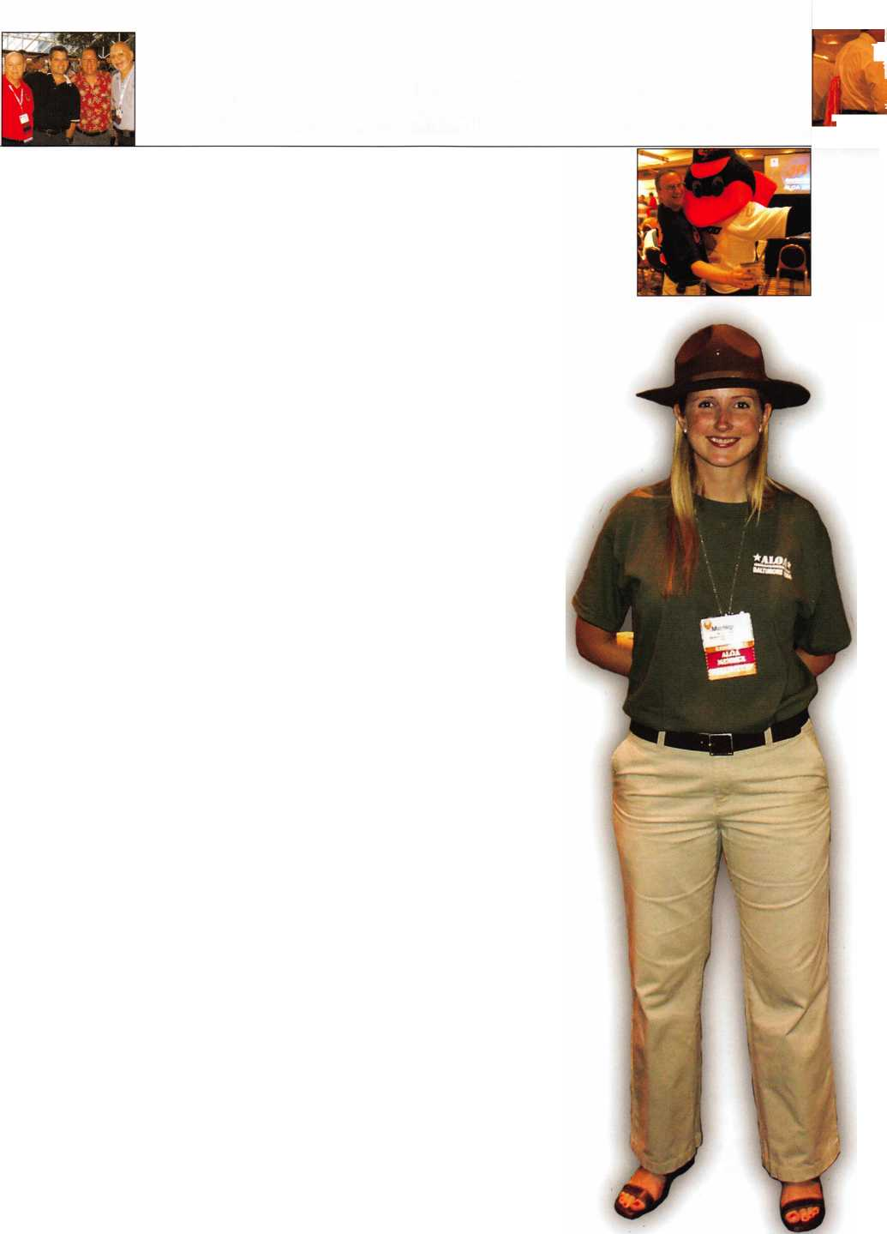

Recognition

*dlu? LLuiO^aC djerOowb h*

Dollars

For *tojJhuL* c*d/o *zcoh*

John Cannon, CML was presented with  
Life Membership for his service  
to the ALOA Board

Ray D’Adamo, CML Keynotes Author of the Year ALOA Scholarship Stan Haney Award

to IR Security and Safety.

is presented

David Thielen, CML wins the coveted ACE award

Scott Henke CPL, CPS and Robert Henke, CRL  
accept the President’s Award.

Scott Henke, CPL, CPS received a  
plaque from the President for his service  
to the ALOA Board

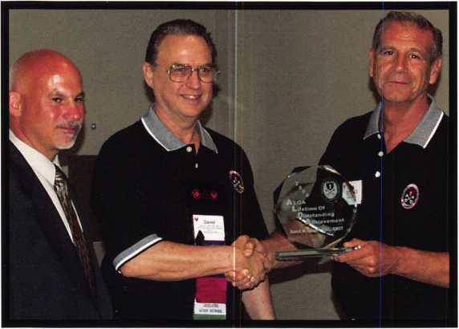

Emotional Surprise

David Lowell, CML, CMSTWins ALOAs Highest Honor

This ALOA Lifetime of Outstanding Achievement (ALOA) Award recognizes one of the many deserving people who spend a large part of their lifetime helping their colleagues. These people should be rec­ognized for their achievements in the fellowship oflocksmithing. Ln a speech by Bob Stafford, CML, David Lowell, CML, CMST was described as calm under pressure. uEven though hes had his ups and downs, he has always handled it in a calm and soothing man­ner. For years, he has spent long days, nights, holidays, and week­ends defending and fighting for the rights of locksmiths.

**32**

Keynotes • September 2004

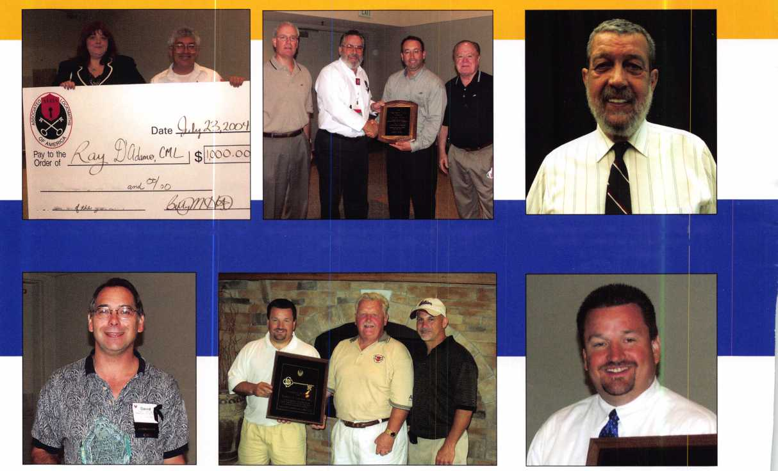

• • •

By the numbers



Over 3,500 participants

11 1

international  
attendees from  
29 different  
countries all  
around the  
world.

All 50 of the  
U.S. states  
were repre-  
sented,  
including  
Puerto Rico.

**New!** Keedex Stainless Steel Armored Door Loops

ALL

STAINLESS STEEL

DESIGN

STAINLESS

CONDUIT

STAINLESS STEEL  
END PIECES

STAINLESS STEEL

MOUNTING SCREWS

COSTS NO MORE  
THAN MOST DOOR  
LOOPS THAT HAVE  
PLASTIC END PIECES

Call or write today for your free catalog!

FROM YOUR

DISTRIBUTOR

MADE IN U.S.A.

Keedex, Inc.

12931 Shackelford Lane



Garden Grove, CA 92841  
714-636-5657 • Fax: 714-636-5680

"Ideas That Work”

e-mail: [info@keedex.com](mailto:info@keedex.com)

[www.keedex.com](http://www.keedex.com)

An average of  
300  
students  
attending  
ACE classes  
each day.

Over $40,000 raised by auction for the ALOA Scholarship Foundation.

597 total  
hours of  
professional  
instruction.

Keynotes • September 2004

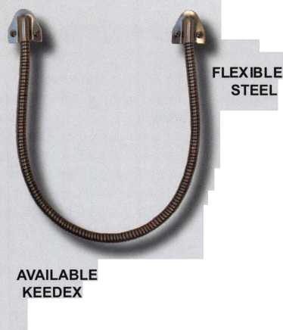

Electronic Safe Locks: Motors and Solenoids

by Brian Costley, CML, CMST

Editor's Note: The following article appeared in the July/August 2004 issue of  
Keynotes ®. Due to a new software conversion technique, all of the numbers  
were deleted from the article. We apologize for any confusion and now  
present the article in it's entirety.

In the world of electronic safe locks, there is a confusing  
plethora of features and functions, but the job of physically  
blocking the safe's boltwork is usually accomplished by either  
a motor or a solenoid. Why two blocking systems? Well, why  
were there both roller fences and drop levers in the heyday  
of mechanical safe locks? The answer is obvious. Each sys-  
tem has its strengths and each offers something different to  
the end user.

Sargent & Greenleaf's first foray into electronic safe locks  
some twenty years ago resulted in a futuristic time lock known  
as the ETL, or Electronic Time Lock. It used a primary and sec-  
ondary backup motor to move the blocking bolt.

The company's initial attempt at producing an electronic safe  
lock resulted in the 6100 ECL. It used a large solenoid that

was connected

directly to the  
lock bolt. It  
was very  
dependable,  
but consumed  
batteries rapid-  
ly. The ECL  
required eight  
AA batteries  
that needed to  
be replaced  
frequently.

Also, the sole-  
noid mecha-  
nism was very  
sensitive to  
bolt side pres-  
sure. As a  
result, the lock  
design was  
scrapped in  
favor of devel-  
opment of a  
motor-driven  
mechanism  
that became  
the 6120,  
introduced in  
1994.

The motorized  
design was  
less suscepti-  
ble to bolt side  
pressure than  
the earlier  
solenoid lock,  
and consumed  
significantly  
less power,  
allowing it to  
be operated  
thousands of  
cycles on a  
pair of alka-  
line 9-volt bat-  
teries, conve-  
niently housed  
under the key-  
pad. Mind  
you, the 6120  
still was finicky  
in the pres-  
ence of bolt  
side pressure,  
but the effects  
were notice-  
ably reduced.

These two  
advancements

made the motor-driven design the mechanism of choice at that time.

In the intervening ten years, the 6120 has undergone a host of engineering revisions, the most sweeping some three years ago. The most significant change in the history of the product was implemented at that time. It involved the addition of a deadlocking system to increase the lock's security and protect the drive mechanism from damage caused by mechanical shock, end pressure, and less than perfect installations. It marked a major stride in increasing the performance and durability of the 6120. Also benefiting from the enhancement was the model 61 23, which shares the same mechanical design, but incorporates more sophisticated electronics to provide for more programming capabilities.

Ten years after the introduction of the 61 20, Sargent & Greenleaf has released the Z02 Rotarybolt™ lock.

Technically, we can't say it's S&G's first solenoid lock, even though it's the first lock of this design offered for sale by the company.

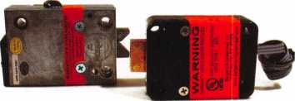

S&G’s new Rotarybolt Z02 lock on the left, and the cur-  
rent model of the 6120 on the right.

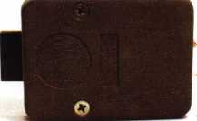

The very first production model of the Sargent &  
Greenleaf 6120.

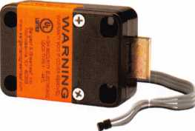

A current model 6120. Note the bolt-through cover. This  
model incorporates a deadlocking bolt.

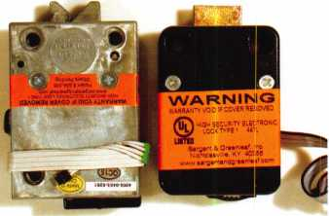

The new Rotarybolt Z02 compared to a current produc-  
tion 6120 lock.

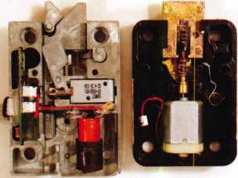

Covers have been removed to reveal the inner workings  
of both locks. Note the solenoid in the Z02 and the motor  
mechanism of the 6120.



Keynotes • September 2004

The Z02 is, in many ways, a radical departure from the other locks in S&G's line. The obvious difference, of course, is the use of a solenoid mechanism to block the bolt. The lock bolt is designed along the same lines as the latch found on better grades of mortise door locks. Once the solenoid is released by entering the correct code for the lock, pressure of the safe's boltwork against one component of the lock bolt causes the other component to move into the lock case. This arrangement leads to very smooth operation and extended life.

The solenoid design is very efficient. It lets the Z02 operate for approximately 8,000 cycles on a single alkaline 9-volt battery. In comparison, the 6120 will open and close about 8,000 times on a pair of 9-volts. In both cases, the cycle fig­

ures are for locks that do not utilize time delays. This feature draws additional power, and the increased draw is a func­tion of the time delay duration. In other words, longer time delays eat up more battery life.

Due to the bolt design, the Z02 is a handed lock, and is available in both left-hand and right-hand models. The follow­ing diagrams explain which is required for the four standard mounting configurations that are used in all safes currently manufactured.

The Rotarybolt Z02 can be used with any keypad currently used with the 6120 and 6123, which includes both one-bat­tery and two-battery models. The one-battery keypad is a nat­ural for the Z02 because of the lock's low current draw.

fha fouf kxics mmrikitBhf bsiow <re iw sane isft4md anodal {Ml Eack «s shown in om of the four slsndbni inouAttBo

psiM. EoA is itpdifi os i mould h§ sun by loflfci§ alttie bode (jnsirii} of it snh Aw.

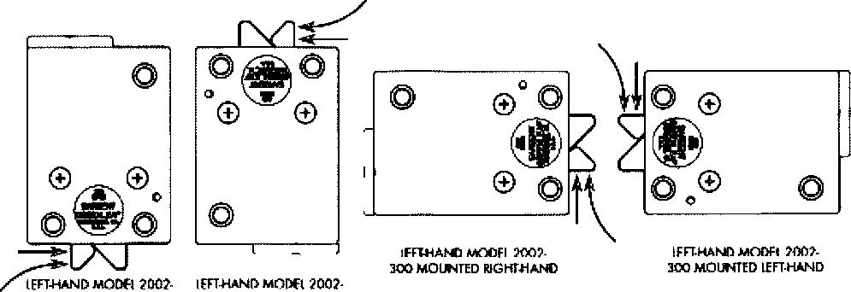

3DD MQUNVBD VBmCAL JOT MCUNf® VEimGALUP

The four locks imediately below are oil the same right-hand model (Model 2002-200 Rotarybolt 2 ~J. Each is shown in on# of th# four standard mounting positions. Each is depicted as it would be seen by looking at the bock (inside) of th# serf# door.

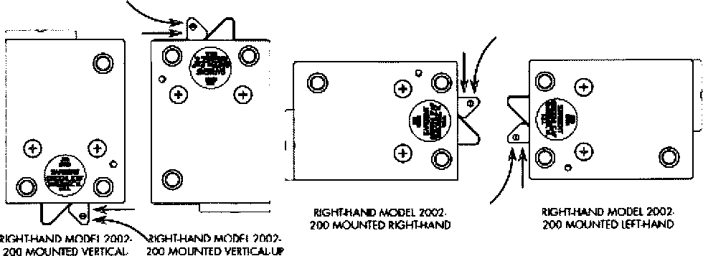

DOWN

**35**

Keynotes • September 2004

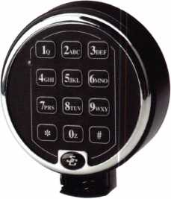

The one-battery keypad with slide-out battery compartment.

Here, the anti-shock component of the Rotarybolt Z02 has been removed  
to provide a clearer view of the solenoid plunger.

The solenoid of the Z02 has been moved to the unlocked position, and the  
6120’s bolt has been fully retracted.

The Rotarybolt Z02 paired with S&G’s one-battery keypad.

In this application, the keypad offers a couple of important con­sumer advantages. First, it makes changing the battery extremely easy and quick. Just pull out the battery compartment, drop out the depleted battery, install a fresh one, then slide the compartment back into the keypad's base. The entire process takes less than five seconds.

The other advantage (and it's a big one) is that the end user has no access to the lock cable. This eliminates the possibility of cable damage during battery changes.

The Z02 footprint is just slightly larger than that of the 61 20 and S&G's standard mechanical safe locks, so it's an easy retrofit in most safes. Also, the three mounting screw locations conform to S&G's Magic Module concept. That means that a safe's mounting plate which has been prepared for a 6730 or 6120 will also accommodate a Z02 without drilling and tapping new mounting screw holes. Metric M6 and X 20 mounting screws are provided with the lock.

When it comes to software features, the Z02 is loaded. It's pro­gramming is exactly like that of the S&G 6123 motorized safe lock. Features include:

* Management Reset Code—Each lock is shipped with a pre­programmed MRC so that control of the lock can be regained if the master code is lost or forgotten.
* Lockout Penalty Timer—Random code entry attempts are discouraged by a five minute lockout timer that activates if four or more incorrect codes are entered in a row.
* Master Code—Performs all programming of the lock without the need for any external devices.
* Supervisor Code—Sets, changes, and deletes user codes, but cannot tamper with time delay features or the Master Code.
* Five User Codes—Holders of these codes can open the safe and can change their own codes.
* Time Delay Override Code—This special code is not subject to time delays, and can be programmed to work in a supervised or unsupervised manner.
* Three Modes of Operation—Single User Mode requires any single code to open the lock, Dual User Mode requires two valid codes to open the lock, and Supervisor/Subordinate Mode (sometimes referred to as Manager/Employee Mode) requires the lock to be activated by the Master or Supervisor Code before User Code holder can open the safe. Similarly, the lock can be deactivated by the Master or Supervisor Code holders.
* Time Delay—Delays of up to 99 minutes can be set, and the Time Delay Opening Window can be set from two to nine minutes.

The latest addition to S&G's lineup of electronic safe locks offers yet another choice in the profitable quest to give customers what they want—the convenience and power of electronic safe locks.

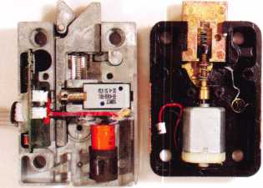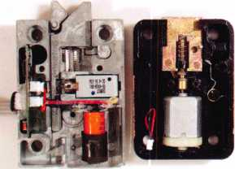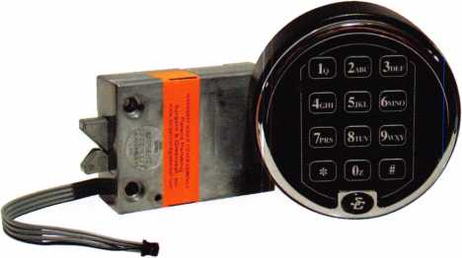

Keynotes • September 2004

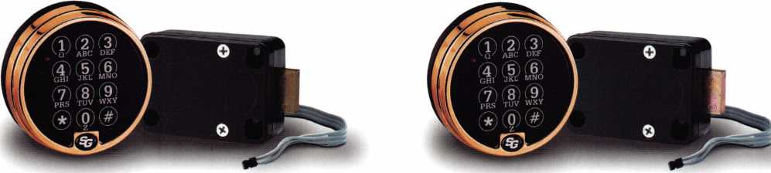

**Before. After.**

Can you see the difference?

**Download our Free Electronic Safe Lock Guide Today!**

**[www.sargentandgreenleaf.com/guide.pdf](http://www.sargentandgreenleaf.com/guide.pdf)**



**SARGENTANDGREENLEAF**

A lock on security.

**With our latest electronic locks, it's what you can't see that really counts.**

**Continuous improvement and smart design are a way of life at S&G. Improvements like our new deadlocking capability that provide an even higher level of security and durability in boltwork blocking applications.**

**And all of our electronic locks offer innovative features that make them more reliable, secure, and easy to use. Features like our advanced, motor-driven design that guard against bouncing and vibration attacks. Simple, yet clever innovations like putting our keypad connector outside the safe for convenient servicing. And the unique advantage of easily programming our locks using only the keypad.**

**Our electronic lock family is the broadest in the industry.**

**And it’s built tough and designed to fit most any commercial- grade application you may encounter. But most important, they’re all backed by the S&G customer service and support that’s always there when you need it.**

**So, if you haven’t tried one of our electronic locks lately, contact your S&G Distributor and see the difference.**

**[www.sargentandgreenleaf.com](http://www.sargentandgreenleaf.com)**



Convention Update

ALOA's 2004 Convention was huge success for the Government Relations Department! I enjoyed having all of you stop by the booth to ask questions, talk about legislation and grab a few bags of free popcorn. Our legislative meeting was not only well attended, but very productive. We had a chance to go around the room and hear the issues and concerns facing locksmiths all over the country. Based on the feedback I received at both the booth and the meeting, I will be carefully crafting a plan of action for the coming months.

Without a doubt, the legislative highlight of the convention was a meeting with automobile manufacturers. For those of you unfa­miliar with our current situation, ALOA has started the process of very detailed discussions with these automobile manufactur­ers. These discussions are intended to help us attain access to key codes, transponder codes, tools, etc. which are required to return a locked-out car to driveability. Almost every major man­ufacturer was represented either in person or via teleconference at this meeting. A major result from Baltimore was that lock­smiths and their automotive issues were officially recognized through the formation of a locksmith sub-committee of the National Automotive Service Task Force (NASTF). I am proud to say that I will be acting as co-chairman of this group.

Many manufacturers stayed after the meeting and toured ALOA's show floor. One manufacturer remarked to me how impressed he was by the professional appearance of every­thing. His newfound respect for ALOA and the work we do, will go a long way in helping us accomplish our goals.

We have set up a teleconference with the manufacturers for September and will be attending the NASTF meeting in early November.

Association Health Plan Legislation UPDATE:

Key Senators Weigh-In on Association Health Plan Bill

The outlook for Senate consideration of the Small Business Health Fairness Act (S. 545) during the remainder of the 108th Congress remains in doubt as Congress recessed for the sum­mer. During July, the legislative process in the Senate ground to a virtual halt as election-year political posturing completely dom­inated the nation's capital. Even legislation with 60 or more pledged votes was blocked due to the desire of Senators from both parties to offer "political" amendments to bills on the

Senate floor. When Congress returns in early September, with the Presidential and Congressional elections in full swing, the Senate's agenda is likely to be driven largely by the dynamics of the political campaigns leading up to the November 2nd elections.

Health reform issues continue to be a hot topic in Washington, DC, as public opinion polls show that concerns over access to affordable health benefits will be a major issue in this year's election campaigns. On July 12, Senate Majority Leader Bill Frist (R-TN) gave a major health care policy speech, in which he laid out his "vision" for the future of the U.S. health care system. It is clearly a positive sign that AHPs are included in Senator Frist's vision of the future of health care. In his speech, Frist said that, "when we look at cost and affordability, I would give indi­viduals in small businesses that purchasing clout. And you do that through establishing purchasing pools, you do it through what is popular here legislatively, and that is association health plans." While Frist has not given any firm indication of how or when he would pursue specific legislation on the issues outlined in his speech (including the AHP legislation), it is certainly an encouraging development to see the most influential Republican on health care issues, other than President Bush, speaking in favor of the AHP legislation!

Meanwhile, Senator Judd Gregg (R-NH), Chairman of the Senate Health, Education, Labor and Pensions Committee, expressed concerns about the AHP bill in a letter to the editor of the Manchester, New Hampshire, Union Leader on July 29. Gregg's letter stated that, while the concept behind the AHP leg­islation "has merit, the problem is in the details." Gregg further said that he "is putting finishing touches on a bill that captures the benefits of AHPs without the controversial elements," by which he presumably is referring to his "insurance market reform" proposal that was outlined in the Senate Uninsured Task Force report released in May. An earlier news article in the Union Leader quoted a Gregg spokesperson as saying the Senator "opposes" AHPs because the bill would "allow some insurers to charge their employees much higher rates than oth­ers." A July 30, 2004, article in the Bureau of National Affairs Daily Report for Executives repeated the statement that Senator Gregg is opposed to the AHP bill and will offer alternative legis­lation (see attached articles).

It is extremely disappointing to learn of such comments from Senator Gregg, especially when they appear to reflect a lack of understanding about the specific provisions S. 545. Gregg's comments come at time when several organizations have requested meetings with the Senator and/or his staff to discuss the specific details of the bill. It is frustrating that Senator Gregg

Keynotes • September 2004

continues to refuse to discuss how the AHP bill might be amend­ed to address his concerns. Organizations are encouraged to re-energize their grass roots efforts with Senator Gregg in New Hampshire.

There will likely be substantial activity in Washington, DC, on health care issues this fall. First, in early September, the Kaiser Family Foundation is expected to release its annual health bene­fits study, which will include information on insurance premium increases. Information showing a continuing trend of substantial premium increases among small and medium-sized employers will be helpful in making the case to Congress that the AHP leg­islation is needed to combat the ever increasing cost of health benefits. In late September, the U.S. Census Bureau is expected to release the number of Americans who were uninsured during calendar year 2003.

The magnitude of the growth of the uninsured will surely be the subject of much discussion within the context of the election cam­paigns, and could provide a further impetus for the Bush Administration to increase the pressure on the Senate to take action on the AHP legislation. Thus, opportunities for activity in the AHP legislation could arise in the fall. In addition, there is a good possibility of a lame-duck session of Congress after the elections, and this also could present opportunities for legislative action.

With Congress in recess, the month of August provides great opportunities for grass roots efforts with Senators. Most Senators will be in their state offices for a considerable portion of August, and now is a good time to request a meeting to discuss their position on S. 545. In addition, organizations should have their members send letters or make calls to Senators in their state offices. Such contacts should request that the Senator become an official cosponsor of S. 545, or at least provide a firm com­mitment to vote for the bill in the event that it is brought up on the Senate floor.

President Bush is expected to unveil a new health reform propos­al at the Republican National Convention, which begins at the end of August, as part of is reelection campaign. However, it is expected that President Bush will continue to make enactment of the AHP bill one of his top health care priorities as he cam­paigns in the fall. The 2004 Democratic Platform, approved at the Democratic Convention in late July, does not mention the AHP legislation.

Regards,

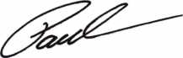

Paul Kanitra

Government Relations Manager  
Associated Locksmiths of America

LEGISLATIVE ACTION NETWORK

You’re a professional locksmith,  
not a professional lobbyist.

You can’t be on the steps of every state capitol and walking the halls of the federal government to protect your profession, but...

WE CAN!

The ALOA Legislative Action Network (LAN) needs Your support for the Voice of Our Profession.

The ALOA Legislative Action Network is constantly working to influence legislation that’s important to the locksmithing profession. We are working in your best interests to promote legislation that will have a posi­tive impact on our proud profession; while preventing or limiting legislative efforts that are harmful. To con­tinue, we need your help to ensure the success of our legislative program for 2004!

If you contribute $25-$99.99 to the Legislative Action Fund, you automatically become a member of the Legislative Action Network (LAN). The LAN is an important tool in raising the standards of our profes­sion through the legislative process by making sure that locksmiths have the final say in how our industry will be run. As a LAN member, you will receive:

* The Legislative Action Network Update alerting you to important legislation in your state and around the country.
* Networking opportunities with ALOA members who share the belief that legislative involvement is important to the effectiveness of our association.
* A listing of your state representatives and senators including capital and district addresses, and phone and fax numbers on both hard copy and disk.
* A comprehensive guide to lobbying in your state capital, so you can be the "voice of ALOA" to legis­lators.
* LAN stationary and envelopes for sending official letters to legislators, lobbying on ALOA’s behalf.
* A lapel pin designating you as a special ALOA LAN member,
* Recognition in Keynotes magazine.
* An invitation to an exclusive reception at the annu­al ALOA convention for LAN members.

When you donate $100 or more, you become part of the heart of the legislative program through LAN membership and receive the following:

* A reserved place of distinction on the special LAN Council
* Discounts on ALOA bookstore items and a 10 % rebate on all ACE classes.
* Complimentary Legislative Convention merchan­dise.
* It’s easy to do Your part...just join TODAY!!

NOTE: Contributions or gifts to the Associated Locksmiths of America, Inc. are not tax deductible as charitable contributions or as business expenses under IRC - 162(e).



Keynotes • September 2004

Classifieds

EMPLOYMENT

FOR HIRE

LOCKSMITH WANTED

Busy shop in Woburn, MA is looking for experienced locksmiths to join our team. If you're a self-motivated hard worker willing to work reasonable hours and be compensated for your abilities, this is for you. We have a large client base for commercial, residential, safes, door and glass storefronts and automotive customers including 2 AAA contracts. Please call John for more information at 781-933-9999 or send resume to: Locks & Keys Inc., P.O. Box 222 • Woburn, MA 01801 (all inquiries kept strictly confidential)

FULL TIME SENIOR LOCKSMITH

Full time senior locksmith needed for fast growing Bank Security Company in Eastern Pennsylvania. Responsibilities include serv­ice and maintenance of vaults, safes, time locks, safe deposit boxes, teller lockers, and after hours depositories. No automo­bile or residential lock work involved. Geographic area covers eastern PA and all of NJ and DE with Company-provided lock van. Benefits include competitive pay rates, 401K, healthcare, and flexible work environment. Send resume and salary requirements to [Jobs@GilbertsonGroup.com](mailto:Jobs@GilbertsonGroup.com) or fax them to 610-466-9019.

IN-ST0CK...M0RE SAFES

***FREE Freight Program***

***(30 States)***

AMSEC FireKing **Baffll** HAYMAN MEIUNK y/CTOR

**TURfl tO**

**WHOLESALE SERVICE**

800-848-9790

MECHANICAL SALESMAN DESIRED!

Bass Security Services, Inc. is looking for a Mechanical Salesman to fill a position in the Sales Department of our Cleveland Ohio office. The ideal candidate must possess excep­tional communication skills and 2-3 years of mechanical sales experience. For more information call 800-523-1422 x.157 or fax a resume to 888-774-8900 or e-mail [sales@bass-security.com](mailto:sales@bass-security.com)

EXPERIENCED LOCKSMITH WANTED

Charlottesville, VA is seeking an experienced locskmith. For infor­mation please email [snowderrow@aol.com](mailto:snowderrow@aol.com) or fax resume to 434-971-8021.

SECURITY TECHNICIANS

Looking for experienced, motivated, hardworking technicians and team players. Great income potential. Don't delay and send resume today.

Liberty Lock & Safe

5470 W Sahara Ave Las Vegas, NV 89146 Fax 702-876-5470 or [www.libertylock.com](http://www.libertylock.com)

EXPERIENCED LOCKSMITH WANTED

Experienced Locksmith Wanted for permanent position with 30- year-old company, located on "The Main Line", in the beautiful suburbs of Philadelphia. Commercial, residential, some electron­ics. Excellent pay and benefits. Truck, tools, and uniforms provid­ed. Requires neat appearance, good people skills, clean record, and drug free, able to lift up to 100 pounds. Please fax your resume to Dayton Lock Co. 610-975-0172, or email [ntdayton@icdc.com](mailto:ntdayton@icdc.com).

LOCKSMITH WANTED

Immidiate opening for a full-service locksmith. Commercial and residential. No auto work! Pay and benefits relative to your experience and ability. Monday-Friday operation. Contact Michael Beattie at Professional Lock $ Safe Co. 1575 Main St, Williamantic, CT 06226. 860-423-5513 or 860-742-6386.

Fax resume to 860-423-5604.

EXPERIENCED LOCKSMITH

Established and expanding company in central NJ is seeking experienced help in residential/commercial/auto/access con­trol/safe work. Top pay for top mechanics along with medial, dental, paid vation, no night calls. Apple Locksmith. 4030 Route 9 South, Morganville, NJ 07751.732-970-1500 or fax resume to 732-970-9725. Attn. Andy or Jack.

LOCKSMITH WANTED

Immediate opening at one of Columbus Ohio's largest locksmith companies. If you are a locksmith with three years of commercial experience and want to work 8:30 to 5:00, come join our team! We are a full service security center. Excellent benefits include 401K, health insurance, paid vacation, sick leave, and continu­ing education. Contact Bill or Tim at Golden Bear Lock & Safe, Inc. 614-733-5625, fax 614-733-0004, or email [goldenbearlock@cs.com](mailto:goldenbearlock@cs.com).

EXPERIENCED LOCKSMITHS

Nationwide company needs F/T, P/T independent contractors throughout the U.S.: Nashville/Knoxville, Mobile, Atlanta, New Orleans, Dallas/Houston/San Antonio, Little Rock, Conn., Mass., Rl, NY and Oklahoma. $1500 - $2500 wk. Full Service Ability or "Nite-Owls" a PLUS ie: auto/residn'I/comm-lockout/rekey, etc. MUST have your own vehicle/tools. Please call Paul (617) 921-2758.

WANTED TO BUY/SELL

LOCKSMITH BUSINESS WANTED

Locks & Keys. Inc. is looking to purchase a locksmith shop and/or mobile locksmith business in the Massachusetts/New England area to help grow our current business. If you are considering retiring or would like to sell and stay on as a locksmith with us, please call John at 781-933-9999 to discuss details. All inquiries kept strictly confidential. Thank you for your consideration.

,25+ Function

Multi-Tool

**—** Lifetime Warranty **—**

FOR LOCKSMITHS ONLY

» 25 Functions  
• Services Schlage, Baldwin,

Corbin/Russwin, Lori,

Adams Rite, Master  
padlocks, Medeco, Arrow,

Jackson crossbars and

many more!

Call Toll Free...

888-634-LOCK

[www.lockmantools.com](http://www.lockmantools.com)

MasterCard

Classified Advertising Policy

Classified advertising space is provided free of charge to ALOA members and for a fee of $2.00 per word, $40.00 minimum for non members. Classified ads may be used to ad/ertise used  
merchandise and overstocked items for sale, "wanted to buy" items, business opportunities, employment opportunities/positions wanted and the like. Members or non members wishing to adver-  
tise services or new merchandise for sale may purchase a "Commercial Classified Ad" for a fee of $4.00 per word with a minimum of $100.00. Each ad will run for two issues. For blind boxes  
there is a $10.00 charge for members and non members. All ads must be submitted in writing to the Advertising Sales Department via fax at 817-645-7599 or through an email to  
[adsales@aloa.org](mailto:adsales@aloa.org) by the fifteenth of the month two months prior to issue date. ALOA reserves the right to refuse any classified advertisement that it deems inappropriate according to the stated

purpose of the classified advertising section.

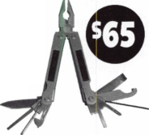

BUSINESS FOR SALE

Colorado Commercial Locksmith Business (Est 1974) located in vibrant golden triangle, adjacent to downtown Denver. Includes vans, equipment, inventory, and loyal customer base. Building also available with additional rental income capacity. Serious inquiries: Mr. Jones (Agent), 1420 Jamaica Street, Aurora, CO, 80010-3498, Fax 303-573-9099.

WHOLESALE SAFE DEPOSIT LOCKS

Allied, Diebold, Herrin, Hall & Mavin, llco, Lefabure, Mosler, Precision, S&G, Security Corp., and Yale. Locks from early 1900s to current. Call or email for lock type and pricing sheet. Quantity discounts. Call WBI at 954-484-2404 or email sales @wbi.us

OVERSTOCK ITEMS

30 Key Machines from Belsaw, Curtis and Mini's to Framon #2, Abloys, Dorn and ITL 900. $50-$ 1200. Hundreds of mostly-orig- inal Schlage knobs, deadbolts and mortise cylinders $3. Latches $l-$5. Weiserbolt knobsets $12. Dexter entry sets $12. Also Dexter/Master and Master/Schlage. One hundred pounds of original Adams-Rite product including 12 pounds of new small repair parts $150. Over 125 car-opening tools plus wedges, instructions and misc. $250. Key racks—Curtis (blue or brown) $25, Cole (yellow) $50, ILC tower (tan) $100.

Tom Bortner 574-264-7374.

EQUIPMENT FOR SALE

Framon #2 never used, HPC 1200 1 10&12 Volt with code cards, ILCO 017 like new with extra cover, HPC code books, Curtis Clipper with extra cams and carriages, MK! and MK2 Code Cutters and component parts, ILCO Speedex, Curtis Key Machine with double tower, Russin Pinning Kit, Corbin Pinning Kit, Kwikset/Titan Pinning Kit, GM-Ford-Chrysler Pinning Kit, Professional Universal Pinning Kit, Foley Belsaw Key Machine, Assorted Keys worth about 2000.00, Stamp ses letters and num­bers, EEZ Readers for 12 makes of vehicles, Rescon Set, 2 Cases for tools, various auto opening tools. 2500.00 Firm. Contact Howard J Perry.Franklin St Box 465, Hallstead PA, 18822-0465, 570-879-4476 or 570-879-2248.

WANTED TO BUY

Illinois licensed locksmith with 17 years experience is looking to purchase an existing small Locksmith business. Must be located in the Chicago area. Contact Mark at 630-428-4476.

FOR SALE

Due to retirement, will accept 10,000.00 cash for 13,400.00 worth of Machines, Tools and Equipment. Will provide inventory to interested parties. Inquire by fax to 863-682-9550 or email to [wemloxmith@aol.com](mailto:wemloxmith@aol.com).

FOR SALE

Convention souvenir collection. Many years and locations. Write: 11315 Hall Drive, Nampa, Idaho 83651 or e-mail [meilan@yc2.net](mailto:meilan@yc2.net).

BUSINESS FOR SALE

FOR SALE

Sarasota Lock & Key Shop—Sarasota's oldest Lock & Key shop. Owner wishes to retire in October 2004. $40,000 for inventory and equipment. Includes registered fictitious name. New owner will have to relocate as building will be sold separately. Inspection invited M-F, 9a-5p. Contact Pete at 1537 State Street Sarasota, FL 34236 • Phone (941)953-3773

FOR SALE

Colorado commercial locksmith business (est 1974) located in vibrant golden triangle, adjacent to downtown Denver. Includes vans, equipment, inventory, and loyal customer base. Building also available with additional rental income capacity. Serious inquiries: Mr Jones (agent) 1420 Jamaica St, Aurora, CO 80010-3498 Fax 303-573-9099

FOR SALE

Well established Lock Shop with AAA contract, 24 hour Mobile Van Service, Commercial, Residential and Turn-Key Auto Shop. No Pun intended! Owners will train and/or assist with the transi­tion of this busy shop with a great location on Highway 101 in the heart of Coos Bay, Oregon. Call Realty Solutions LLC: Ellie Cary 503-620-5533.

FOR SALE

Locksmith business for sale: 4 key machines: Framon Model 2, Framon Model DBM-1, HPC Trace-A-Key (manual) Model 3333, Rytan Key Machine Model 504831. Vast quantities of keys, lock- sets, key blanks, code books, and locksmith tools. Also a 1995 Chevy commercial van fitted for a mobile locksmith shop.

Richard Walther Estate • Norma Walther, Executor • 2024 Garden Avenue Waverly, Iowa 50677 • 318-352-2138



IQCKMflSTIRS

INCORPORATED

800.654.0637

lockmasters.com



**SAFE CORPORATION**

MANUFACTURES OF QUALITY DEPOSITORY SAFES AND CHESTS

DISTRIBUTING FROM WAREHOUSES IN

* LOS ANGLES, CA
* CHICAGO**>** IL
* GLASSBORO, NJ

A & B is now a stocking distributor

for Mutual Safes

featuring

JIUI II iy

**ll**

0

AB-4-30-3S AB-9-2 WS 10-2

Chose from over 75 models in stock

We ship your order within

24 hours

See us

*of* [www.a-bsafecorp.com](http://www.a-bsafecorp.com)  
800-253-1267  
Fax 856-863-1208

CALL FOR YOUR  
CATALOG TODAY

|  |  |  |  |  |  |  |  |
| --- | --- | --- | --- | --- | --- | --- | --- |
|  | a | s s | ' \ | 0 c | i a 1 | ■ e |  |
| 9 , |  | m | e | m b | e r s |  |  |

Distributor

**1 st In Hardware, Inc.**

Phone: 866-397-9900 Fax: 866-646-0045 www. 1 stinhardware.com

**ADI Inc.**

Phone: 631-692-1000 Fax: 631-692-3011

**Accredited Lock Supply Co.**

Phone: 800-652-2835 Fax: 201-865-0030 [www.acclock.com](http://www.acclock.com)

**Ace Lock & Security Supply**

Phone: 800-223-5625 Fax: 908-688-2442 [www.acelock.com](http://www.acelock.com)

**Andrews Wholesale Lock Supply**

Phone: 717-272-7422 Fax: 717-274-8659 [www.andrewslock.com](http://www.andrewslock.com)

**Boyle & Chase Inc.**

Phone: 800-325-2530 Fax: 800-205-3500 [www.boyleandchase.com](http://www.boyleandchase.com)

**Chinrose International**

Phone: 503-357-7553 Fax: 503-357-5522 [www.chinrose.com](http://www.chinrose.com)

**Clark Security Products**

Phone: 888-784-1311 Fax: 619-718-7333 [www.clarksecurity.com](http://www.clarksecurity.com)

**Cook's Building Specialties**

Phone: 505-883-5701 Fax: 505-883-5704

**Dire's Lock & Key Company**

Phone: 303-294-0176 Fax: 303-294-0198

**Direct Security Supply, Inc.**

Phone: 800-252-5757 Fax: 800-452-8600

**Discount Key Machines.Com/Busch**

Phone: 800-332-8724 Fax: 407-363-4666

**Doyle Security Products**

Phone: 800-333-6953 Fax: 612-521-0166 [www.doylesecurity.com](http://www.doylesecurity.com)

**Dugmore and Duncan, Inc.**

Phone: 888-384-6673 Fax: 888-329-3846

**E. L. Reinhardt Co., Inc.**

Phone: 800-328-131 1 Fax: 651-481-0166 [www.elreinhardt.com](http://www.elreinhardt.com)

**Ewert Wholesale Hardware**

Phone: 800-451-0200 Fax: 708-597-0881

**Fairway Supply, Inc.**

Phone: 214-350-0021 Fax: 214-352-4299 [www.fairwaysupply.com](http://www.fairwaysupply.com)

**Foley-Belsaw Company**

Phone: 800-821-3452 Fax: 816-483-5010 [www.foley-belsaw.com](http://www.foley-belsaw.com)

**Fried Brothers Inc.**

Phone: 800-523-2924 Fax: 215-592-1255 [www.fbisecurity.com](http://www.fbisecurity.com)

**Hans Johnsen Company**

Phone: 214-879-1550 Fax: 214-879-1530 [www.hjc.com](http://www.hjc.com)

**Hardware Agencies, Ltd.**

Phone: 416-462-1921 [www.hardwareagencies.com](http://www.hardwareagencies.com)

**IDN Incorporated**

Phone: 817-421-5470 Fax: 817-421-5468 [www.idn-inc.com](http://www.idn-inc.com)

**Intermountain Lock & Supply**

Phone: 800-453-5386 Fax: 801-485-7205 [www.intermountainlock.com](http://www.intermountainlock.com)

**International Electronics, Inc**

Phone: 800-343-9502 Fax: 617-821-4443

**Jo Van Distributors**

Phone: 416-752-7249 Fax: 416-752-7282 [www.jovanlock.com](http://www.jovanlock.com)

**Lockmasters, Inc.**

Phone: 859-885-6041 Fax: 859-885-7093 [www.lockmasters.com](http://www.lockmasters.com)

**Locks Company**

Phone: 800-288-0801 Fax: 305-949-3619

**Locksmith Ledger International Top Notch Distributors, Inc..**

Phone: 770-886-0800 Phone: 800-233-4210

Fax: 770-889-7703 Fax: 800-854-4146

[www.lledger.comwww.topnotch.bz](http://www.lledger.comwww.topnotch.bz)

**M. Zion Company Turn 10 Wholesale**

Phone: 212-349-8677 Phone: 800-848-9790

Fax: 212-964-0495 Fax: 800-391 -4553

[www.mzion.com](http://www.mzion.com)

**McDonald Dash Locksmith Supply**

Phone: 800-238-7541 Fax: 901-366-0005 [www.mcdonalddash.com](http://www.mcdonalddash.com)

**U.S. Lock Corp.**

Phone: 800-925-5000 Fax: 800-338-5625 [www.uslock.com](http://www.uslock.com)

**Monaco Lock Co.**

Phone: 800-526-6094 Fax: 800-845-5625 [www.monacolock.com](http://www.monacolock.com)

**Omaha Wholesale Hardware**

Phone: 800-238-4566 Fax: 402-444-1664 [www.omahawh.com](http://www.omahawh.com)

**RA-Lock Company**

Phone: 972-775-6301 Fax: 972-775-6316 [www.ralock.com](http://www.ralock.com)

**Security House**

Phone: 905-669-5300 Fax: 905-660-6313 [www.securityhouselock.com](http://www.securityhouselock.com)

**Security Distributors**

Phone: 800-333-6953 Fax: 612-524-0166

**Security Lock Distributors**

Phone: 800-847-5625

Fax: 800-878-6400

[www.securitylockdistributors.com](http://www.securitylockdistributors.com)

**Shin-An Enterprise Inc.**

Phone: 718-225-5380 Fax: 718-819-0723

**Southern Lock and Supply Co.**

Phone: 727-541-5536 Fax: 727-544-8278 [www.southernlock.com](http://www.southernlock.com)

Manufacturer

**A & B Safe Corporation**

Phone: 800-253-1267 Fax: 856-863-1208 [www.a-bsafecorp.com](http://www.a-bsafecorp.com)

**ABUS Lock Company**

Phone: 800-352-2287 Fax: 602-516-9934 [www.abus.com](http://www.abus.com)

**Access Security Products Ltd.**

Phone: 905-337-7874 Fax: 905-337-7873 www. access-safe .com

**Adams Rite Mfg Company**

Phone: 800-872-3267 Fax: 800-232-7329 [www.adamsrite.com](http://www.adamsrite.com)

**Adesco Safe Mfg. Company**

Phone: 800-694-9340 Fax: 562-408-6427 [www.adesco.com](http://www.adesco.com)

**Adrian Steel Company**

Phone: 800-677-2726 Fax: 517-265-5834 [www.adriansteel.com](http://www.adriansteel.com)

**All Five Tool Company, Inc.**

Phone: 860-583-1691 Fax: 860-583-4516 [www.all5tool.com](http://www.all5tool.com)

**Stone & Berg Wholesale**

Phone: 800-225-7405 Fax: 800-535-5625

**The Locksmith Store Inc.**

Phone: 847-364-51 1 1 Fax: 847-364-5125 [www.locksmithstore.com](http://www.locksmithstore.com)

**Timemaster Inc.**

Phone: 859-259-1878 Fax: 859-255-0298 [www.time-master.com](http://www.time-master.com)

**American Lock Company**

Phone: 708-534-2000 Fax: 708-534-0531 [www.armericanlock.com](http://www.armericanlock.com)

**American Security Products**

Phone: 909-685-9680X1083 Fax: 909-685-9685 [www.amsecusa.com](http://www.amsecusa.com)

S

i

**2**

Keynotes • September 2004

**associate**

members

**Best Metaline Inc.**

Phone: 714-441-0098 Fax: 714-441-0977

**Bianchi USA, Inc.**

Phone: 800-891-2118 Fax: 216-803-0202

**Buddy Products**

Phone: 800-886-8688 Fax: 312-733-8356 [www.buddyproducts.com](http://www.buddyproducts.com)

**CCL Security Products**

Phone: 800-733-8588 Fax: 847-537-1800

**COMPX Security Products**

Phone: 864-297-6655 Fax: 864-297-9987 [www.compxnet.com](http://www.compxnet.com)

**D&D Technologies (USA), Inc.**

Phone: 714-677-1300X292 Fax: 714-677-1299 [www.ddtechusa.com](http://www.ddtechusa.com)

**DETEX Corp**

Phone: 800-729-3839 Fax: 830-620-6711 [www.detex.com](http://www.detex.com)

**DORMA Architectural Hardware**

Phone: 717-336-3881 Fax: 717-336-2106 [www.dorma-usa.com](http://www.dorma-usa.com)

**Datakey Electronics**

Phone: 952-746-4066 Fax: 866-289-4212 [www.datakeyelectronics.com](http://www.datakeyelectronics.com)

**Don-Jo Manufacturing, Inc.**

Phone: 978-422-3213 Fax: 978-422-3467 [www.don-jo.com](http://www.don-jo.com)

**Door Controls International**

Phone: 800-742-3634 Fax: 800-742-0410 [www.doorcontrols.com](http://www.doorcontrols.com)

**ESP Lock Products Inc.**

Phone: 800-434-8960 Fax: 978-562-9859

**FireKing Security Products**

Phone: 800-457-2424 Fax: 800-896-6606 [www.fkisecuritygroup.com](http://www.fkisecuritygroup.com)

**Framon Manufacturing Company Inc.**

Phone: 989-354-5623 Fax: 989-354-4238 [www.framon.com](http://www.framon.com)

**HPC, Inc.**

Phone: 847-671-6280 Fax: 847-671-6343 [www.hpcworld.com](http://www.hpcworld.com)

**HY-KO Products Co.**

Phone: 330-467-7446 Fax: 330-467-7442

**Hammerhead Industries, Inc.**

Phone: 805-658-9922 Fax: 805-658-8833 [www.gearkeeper.com](http://www.gearkeeper.com)

**Ingersoll Rand SSA**

Phone: 317-613-8025 Fax: 317-613-8068 [www.schlagelock.com](http://www.schlagelock.com)

**Jet Hardware Mfg., Co.**

Phone: 718-257-9600 Fax: 718-257-0973 [www.jetkeys.com](http://www.jetkeys.com)

**KABA ILCO Corp.**

Phone: 252-446-3321 Fax: 252-446-4702 [www.kaba-ilco.com](http://www.kaba-ilco.com)

**KEY-BAK/West Coast Chain Mfg.**

Phone: 909-923-7800 Fax: 909-923-0024 [www.keybak.com](http://www.keybak.com)

**Keri Systems Inc.**

Phone: 408-451-2520 Fax: 408-441-0309 [www.kerisys.com](http://www.kerisys.com)

**Knaack Manufacturing Co.**

Phone: 800-456-7865 Fax: 815-459-9097 [www.weatherguard.com](http://www.weatherguard.com)

**LAB Security**

Phone: 800-243-8242 Fax: 860-583-7838 [www.labpins.com](http://www.labpins.com)

**La Gard Inc.**

Phone: 310-325-5670 Fax: 310-325-5615 [www.lagard.com](http://www.lagard.com)

**Lock America, Inc.**

**Dba L.A.I. Group**

Phone: 714-373-2993 Fax: 714-373-2998 [www.laigroup.com](http://www.laigroup.com)

**Lucky Line Products, Inc.**

Phone: 858-549-6699 Fax: 858-549-3241 [www.luckyline.com](http://www.luckyline.com)

**M.A.G. Security**

Phone: 714-891-5100 Fax: 714-892-6845 [www.magsecurity.com](http://www.magsecurity.com)

**MUL-T-LOCK USA, Inc.**

Phone: 800-562-3511 Fax: 973-778-4007 [www.mul-t-lock.com](http://www.mul-t-lock.com)

**Medeco Security Locks**

Phone: 540-380-5000 Fax: 540-380-5010 [www.medeco.com](http://www.medeco.com)

**ROFU International Corp.**

Phone: 253-922-1828 Fax: 253-922-1728 [www.rofu.com](http://www.rofu.com)

**Rutherford Controls Int'l Co.**

Phone: 757-427-1230 Fax: 757-427-9549 [www.rutherfordcontrols.com](http://www.rutherfordcontrols.com)

**STRATTEC Security Corp.**

Phone: 414-247-3415 Fax: 414-247-3692 [www.strattec.com](http://www.strattec.com)

**Sargent & Greenleaf, Inc.**

Phone: 800-826-7652X201 Fax: 859-885-3063 [www.sargentandgreenleaf.com](http://www.sargentandgreenleaf.com)

**Sargent Manufacturing Co.**

Phone: 800-727-5477 Fax: 888-863-5054 [www.sargentlock.com](http://www.sargentlock.com)

**Schwab Corp.**

Phone: 765-447-9470 Fax: 765-447-8278 [www.schwabcorp.com](http://www.schwabcorp.com)

**Securitron Magnalock Corp.**

Phone: 775-355-5625 Fax: 775-355-5636 [www.securitron.com](http://www.securitron.com)

**Security Door Controls**

Phone: 805-494-0622 Fax: 805-494-8861 [www.sdcsecurity.com](http://www.sdcsecurity.com)

**Security Solutions**

Phone: 405-376-1600 Fax: 405-376-6870 [www.securitysolutions-usa.com](http://www.securitysolutions-usa.com)

**Townsteel, Inc.**

Phone: 626-858-5080 Fax: 626-858-3393 [www.townsteel.com](http://www.townsteel.com)

**Trine Access Technology**

Phone: 718-829-2332 Fax: 718-829-6405 [www.trineonline.com](http://www.trineonline.com)

**Victor E-lok, Inc.**

Phone: 949-916-1200 Fax: 949-916-1300 [www.victorelok.com](http://www.victorelok.com)

**Videx Inc.**

Phone: 541-758-0521 Fax: 541-752-5285 [www.videx.com](http://www.videx.com)

**Wilson Safe Company**

Phone: 215-492-7100 Fax: 215-492-7104 [www.wilsonsafe.com](http://www.wilsonsafe.com)

**YSG Door Security Consultants, Inc.**

Phone: 800-438-1951 Fax: 800-338-0965

Service

Organization

**Allstate Insurance Company**

Phone: 800-859-0247 Fax: 847-326-7509 [www.allstate.com](http://www.allstate.com)

**Cross Country Automotive Services**

Phone: 800-541-2262 Fax: 781-393-0256 [www.argosi.com](http://www.argosi.com)

**Massglass & Door Service**

Phone: 888-742-8837 Fax: 805-497-2255 [www.massglass.com](http://www.massglass.com)

**Webster Safe & Lock Co., Inc.**

Phone: 901-332-2911 Fax: 901-332-2878 [www.webstersinc.com](http://www.webstersinc.com)



Keynotes • September 2004

The Curious Curator Presents

French Masterpieces Part 2 of 2  
by AJ Hoffman, CML

The Bremer Masterpiece

My masterpiece lock turned up in Amsterdam with its original key. Unfortunately it had not been well cared for and has quite a bit of pitting from rust.

A. BREMER is stamped on the piece which joins the comb wards to the piercing wards. Since it is easily removable, this may be a locksmith who repaired this lock, rather than the name of the original master who made it. A few internal parts are not original and it looks as if one of the four bolts was removed and its hole in the edge of the lock plugged.

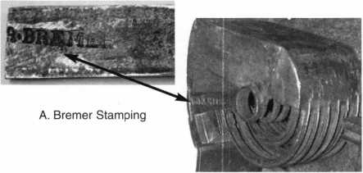

Operating Instructions

Press the central religious figure upward against spring pressure. This raises a latch so you can pull the door open to reveal the keyhole.

Turn the key clockwise to lift Bolt 3A out of engagement with Bolt 3B. This frees Bolt 3B for retracting by sliding Lever C.

Continue turning the key clockwise to lift Lever 2, releasing the deadlock so Bolt 2 can be retracted simultaneously as Bolt 1 is drawn back directly by the key's final movement. Bolt 1 is under spring pressure from Lever 1 and extends automatical­ly as you turn the key back.

Bolt 3B is key retaining. If you slide lever C to retract it, you cannot turn the key all the way back to the removal position because the key needs to throw bolt 3A on its return trip. Bolt 3A cannot be thrown until Bolt 3B is thrown.

Throw Bolt 3B with Lever C.

Turn the key back to the key pull position and remove it. Bolt 1 springs back to its projected position after losing contact with the key bit.

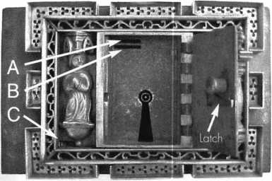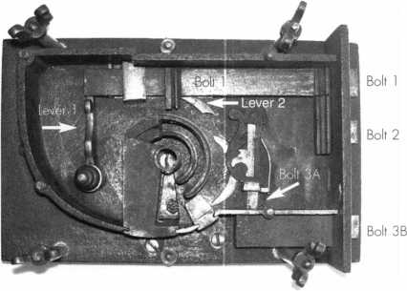

Bremer Lock With Back Cover Removed

At this point, Bolt 1, although square, acts as a spring latch. You can retract it as  
often as you like by sliding Lever B. Bolt 2 remains retracted.

Slide Lever A to project Bolt 2. As it clicks into the locked position, it also dead-  
locks Bolt 1 so you can no longer retract it with lever B. Now all three bolts are  
deadlocked. This operation makes no sense to me and is probably the result of  
jerry-rigging ages ago by whoever removed the fourth bolt.

The Bremer masterpiece lock is too large to show actual size. It is 8 3/16” x 5 1/8” (25.2 cm x 13 cm) and weighs over 9 pounds (4.2 kg).

A.J. Hoffman Collection

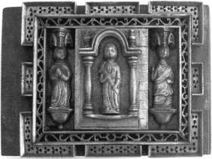

My thanks to Bob Heilemann who fabricated two missing parts and restored this lock to full operation.

Editors Note: Anthony J. Hoffman, III passed away suddenly due to heart failure on Sunday, July 1 1, 2004 at a favorite beach  
near his home in Mission Viejo, California. AJ was a world renowned expert on antique locks and the history of interchangeable  
core cylinders and key systems. Fluent in six languages, AJ was also an accomplished linguist and musician, singing tenor and pro-  
viding pronunciation guidance for Pacific Chorale, one of America's most respected and accomplished professional choruses. He is  
survived by his wife Vivian.



Keynotes • September 2004

PATRIOT

**Offer Your Customers an**

AMERICAN MADE, AMERICAN QUALITY FIRE SAFE ★★★

LOCK:

UL-listed high security Group 11 Sargent & Greenleaf combination lock. Drill-resistant steel hardplate protects the internal lock mechanism.

BODY & DOOR:

Constructed of a  
defense barrier of  
thick outer and

inner steel plates

encasing the

latest high density  
fire barrier  
material.

BOLTWORK:

3-way boltwork system includes six massive 1 ” diameter chrome- plated solid steel bolts

RELOCKER:

Independent spring-loaded relocker activates during burglary attack, securing the boltwork in locked position.

HINGES:

Heavy duty, adjustable solid steel block hinges provide additional security and smooth operation

OPTIONS:

Electronic digital pushbutton locks. Additional shelving available.

ADDITIONAL

FEATURES

Light gray finish is accented with black facia plate. Adjustable shelving included in each safe.

Safe comes mounted on 4 rubber feet (removable) which raise the safe 1 1/8” off the floor. Pre-drilled boltdown hole.

MADE IN THE USA

®

LISTED

**UL Class 350 1 Hour Fire & Impact Rated**

Available in three sizes, the Patriot Vault is built  
according to UL Class 350 standards to withstand  
fires up to 1700°F for 1 hour, while ensuring that  
the internal safe temperature does not exceed  
350°F. Additionally, Patriot Vault has passed the  
rigorous UL Fire Impact test that simulates a safe  
dropping 2 stories after being exposed to extreme  
high heat conditions for 30 minutes, hotbb

**DEFIANT SAFE COMPANY Dallas, Texas**

|  |  |  |  |  |  |
| --- | --- | --- | --- | --- | --- |
| nj | |  |  |  | |
| C=3® |  |  | c |  | 2 |
|  |  |  |  |  | |=o| |
| 11 | |  | 1 |  | __5 |

PV-2015 PV-1713 PV-1512

1-800-225-2984

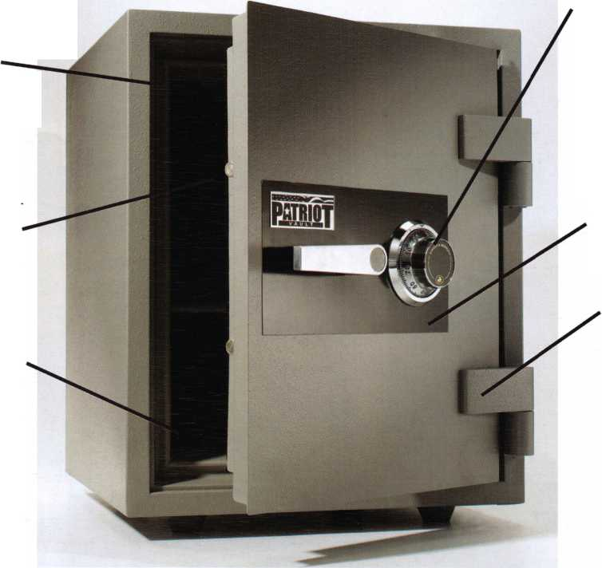

Now

"I've lost my Taurus keys... can you make me a new set?'

NGS STAR XL CAN

Locksmith 8008LXLC

How much of your money have you sent to the local Ford Dealer?

Did you Know...

...the Dealers charge an average of $100 per transponder key?

...you can get the factory transponder tool for less than the cost of doing one key per month?

Use what the Dealers use for complete  
coverage on ALL Ford/Lincoln-Mercury and  
Mazda vehicles equipped with transponder  
keys. The NGS XL CAN offers complete  
transponder coverage including CAN protocol  
and the ability to clear ALL Diagnostic Service Codes

re never on your own

**2004 Software Update and CAN V Interface Module now available**

**© Waekon/Hickok Inc. 2004 All rights reserved.**

|  |  |
| --- | --- |
| r-n1 | |
| HICKOK ■ J |  |
|  |  |
|  |  |
|  | ■ I |

